**OVE & ESPECT**

**Wo rkboo l<**

DR . EM E R S O N EGGE RI CH S WITH

FRITZ RI D EN OU R



THOMAS NELSON

*S i nce 1798*

NASHVILLE DALLAS MEXICO CITY RIO DE JANEIRO BEIJING



Focus on the Family Colorado Springs, Colorado

LOVE & RESPECT WORKBOOK

Copyright © 2005 by Emerson Eggerichs.

All rights reserved. No portion of this book may be reproduced, stored in a retrieval system, or trans­ mitted in any form or by any means-electronic, mechanical, photocopy, recording, scanning, or other-except for brief quotations in critical reviews or articles, without the prior written permission of the publisher.

Published in Nashville, Tennessee. Thomas Nelson is a trademark of Thomas Nelson, Inc.

Thomas Nelson, Inc. books may be purchased in bulk for educational, business, fund-raising, or sales promotional use. For information, please e-mail [SpecialMarkets@ThomasNelson.com.](mailto:SpecialMarkets@ThomasNelson.com)

Published in association with Yates and Yates, **LLP,** Attorneys and Literary Agents, Orange, California.

Unless otherwise marked, Scripture quotations are taken from The New American Standard Bible® (NASB®). Copyright © 1960, 1962, 1963, 1968, 1971, 1972, 1973, 1975, 1977, 1995 by The

Lockman Foundation. Used by permission .

Additional Scripture quotations are taken from the following sources:

Contemporary English Version® (CEv®). Copyright © 1995 by American Bible Society. Used by permission . The King James Version (KJV) . Public domain. The Message (MSG) by Eugene H. Peterson. Copyright © 1993, 1994, 1995, 1996, 2000, 2001, 2002. Used by permission of NavPress Publishing Group. All rights reserved. The Holy Bible, New International Version® (NIV®).

Copyright © 1973, 1978, 1984 by International Bible Society. Used by permission of Zondervan. All rights reserved. The New International Reader's Version® (NIRV®). Copyright © 1996, 1998 International Bible Society. All rights reserved throughout the world. Used by permission of International Bible Society. The New King James Version® (NKJV®). Copyright © 1982 by Thomas Nelson, Inc. Used by permission . *All* rights reserved. '----

Cover Design: Charles Brock, UDG I DesignWorks, Inc. Cover Photo: Steve Gardner, shootpw.com

Interior Design: Rainbow Graphics; Kingsport, TN.

ISBN-13: 9-781-59145-348-2

ISBN-10: 1-59145-348-8

*Printed in the United States of America*

07 08 09 10 11 RRD 12 11 10 9 8

# CONTENTS

_Before You Start Your Study of Love and Respect 6

PART ONE

THE CRAZY CYCLE

SESSION ONE 10

* Introduction
* Chapter 1 - The Simple Secret to a Better Marriage

SESSION TWO 24

* Chapter 2 -To Communicate, Decipher the Code

SESSION THREE 43

* Chapter 3 - Why She Won't Respect; Why He Won't Love
* Chapter 4 - What Men Fear Most Can Keep the Crazy Cycle Spinning

SESSION FOUR 62

* Chapter 5 - She Fears Being a Doormat; He's Tired of "Just Not Getting It"
* Chapter 6 - She Worries About Being a Hypocrite; He Complains, "I Get No Respect!"
* Chapter 7 - She Thinks She Can't Forgive Him; He Says, "Nobody Can Love That Woman!"

4 *00* CONTENTS

**PART TWO**

**THE ENERGIZING CYCLE**

**fSEssION FIVE**

* Chapter 8 - C-0-U-P-L-E: How to Spell Love to Your Wife
* Chapter 9 - Closeness-She Wants You to Be Close

### SESSION SIX

* Chapter 10 - Openness-She Wants You to Open Up to Her
* Chapter 11 - Understanding- Don't Try to "Fix" Her; Just Listen

### SESSION SEVEN

* Chapter 12 - Peacemaking- She Wants You to Say, 'Tm Sorry"

### SESSION EIGHT

* Chapter 13 - Loyalty-She Needs to Know You're Committed
* Chapter 14 - Esteem-She Wants You to Honor and Cherish Her

### SESSION NINE

* Chapter 15 - C-H-A-I-R-S: How to Spell Respect to Your Husband
* Chapter 16 - Conquest-Appreciate His Desire to Work and Achieve

### SESSION TEN

* Chapter 17 - Hierarchy-Appreciate His Desire to Protect and Provide
* Chapter 18 - Authority-Appreciate His Desire to Serve and to Lead

### SESSION ELEVEN

* Chapter 19 - Insight-Appreciate His Desire to Analyze and Counsel

### SESSION TWELVE

* Chapter 20 - Relationship-Appreciate His Desire for Shoulder-to-Shoulder Friendship

**82**

**96**

##### 107

**115**

**128**

**13**...._ _

**153**

**163**

CONT ENTS 5

* Chapter 21 - Sexuality-Appreciate His Desire for Sexual Intimacy
* Chapter 22 - The Energizing Cycle Will Work IfYou Do

**PART THREE**

**THE REWARDED CYCLE**

### SESSION THIRTEEN 179

* Chapter 23 - The Real Reason to Love and Respect

**SESSION FOURTEEN 189**

* Chapter 24 - The Truth Can Make You Free, Indeed
* Conclusion: Pink and Blue Can Make God's Purple

**APPENDIX I**

* Using the *Love & Respect Workbook* in a Group Setting 201

### APPENDIX II

* 1 Peter 3:2: Addressed to God or to Wives? 205

**APPEND IX III**

* Forgiveness Has Two Levels 207

,- **A**-

### PPENDIX IV

* Does Ephesians 5:21 Say Wives Don't Have to Submit to Husbands? 213

### APPENDIX V

* + Sex: Love and Respect First-Then "Just Do It!" 218

### APPENDIX VI

* + Emerson's Additional Commentary 223

**BEFORE You**

**STA RT**

**YouR**

**A ND**

**STUDY OF**

**RE SP ECT**

**LOV E**

• • •

Welcome to the *Love & Respect Workbook* experience. You are about to discover and apply the single greatest secret to a successful marriage. Today, you and your mate can start fresh with the ground-breaking guidance that Dr. Emerson Eggerichs provides in this workbook and the book it accompanies- love *&Respect.* These two books are designed to be companions, so you'll benefit most if you have a copy of the book as well as this workbook.

Based on three decades of counseling experience, as well as scientific and biblical research, the book offers you the information and tools you will need to understand what is wrong in your relationship and begin the process of correcting it. The work­ book gives you and your mate a private place to complete a wide variety of exercises that are crucial to the process of making Dr. Eggerichs' breakthrough techniques a permanent part of your marriage.

Before you start your actual study, here are some helpful hints on how you can bene­ fit most from your experience:

*Come ready to let God help you work onyour marriage.* As you experience *Love &Respect* you will be amazed at how these two simple but powerful concepts can affect your marriage. This is no quick and easy fix, but if you are willing to spend a reasonable amount of time and effort, and make the tiniest of adjustments, this study will change you and your marriage for the better.

*Study at your own pace and preference .* Some of the questions are quite simple-others take more thought and effort. But as you interact with *Love & Respect* concepts, you

BEFORE You STA RT YouR ST UDY O F LovE AND RES PECT . . 7

will begin to see what Emerson is talking about. In Emerson's words, you will "get it" and once you "have it," you will never be the same.

*Get acquainted with how this workbook is constructed.* It covers all the *Love & Respect* book in fourteen sessions. Some sessions cover one chapter of the book, and others cover as many as three chapters. As you go through each chapter, you will note that every subhead denotes a block or section of study, and generally there is at least one question for every section. The goal is to get you involved with what Emerson is say­ ing, to see if you agree or disagree as you apply his concepts to your marriage. When

-spme questions deal with difficult concepts, there is extra input and explanation in the 10rm of Emerson's Additional Commentary (see *Workbook* Appendix VI).

This workbook was designed to be used by both individuals *and* couples, so you'll no­ tice ICONS throughout that will help you understand which questions apply to you.

First, take note that the questions *without* icons apply to *all readers.* In each chapter, be sure to answer all these questions first. Then, take note of the three types of icons used in the workbook. There are certain questions designed especially for men, while others address women only. And some of the questions should be answered as a couple. Here is a quick review:

Unmarked questions should be answered first in each chapter by both the man and the woman.

Men answer these questions.

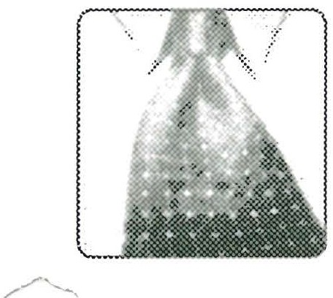

L-JWomen answer the<e questions.

Couples answer these questions together. Answer these questions last in each chapter.

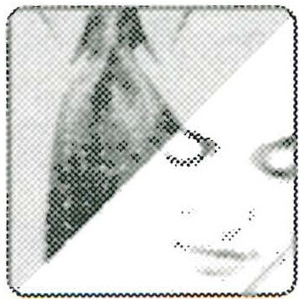

.

*You can study this book solo.* The questions are written primarily for individuals and then for couples. Therefore, if your spouse is not yet interested in *Love & Respect,* you can gain much from working alone. But as you begin putting *Love & Respect* prin­ ciples into action, your spouse may decide to join you!

8 *00* BEFORE You STA RT YouR STUDY OF Lov E A N D RESPECT . . .

*For maximum benefit, study with your spouse.* Virtually every question has a section for spouses studying together. Remember, these questions are marked with an icon of a couple. Both of you should answer these questions together *after* you answer each question individually. As you compare and discuss your answers, you will gain new understanding of each other and how each of you sees your marriage.

*Takeyour time.* There is no hurry and no requirement to cover every last question com­ pletely. Break each session into workable parts. Concentrate on the questions that really speak to your needs as husband and wife.

*Treat each other with Love and Respect.* Because some of the questions probe sensitivr areas, it is possible that tension will develop-even irritation and anger. Your rul --­ should be: when dealing with sensitive issues, be sensitive to each other! If a question becomes a bit too sticky, and one of you doesn't feel up to dealing with it at the moment, table that question for possible discussion later.

*Handle each other with care.* As you proceed, you will soon see that a question may reflect the strength of one spouse and the vulnerability of the other. Where you are strong, or not so sensitive, your spouse is weaker and more sensitive. Where you can quickly see the need to change your attitude or something you are doing, your spouse may struggle, seeming to stubbornly hang on to habits you know have to go! By-words for your study of *love and respect* should be: patient, non-judgmental and forgiving. Always remember that God made us male and female-not wrong, just different. If both of you approach each question with compassion and empathy for each other, there will not be a critical or judgmental spirit on the part of the stronger one, and the vulnerable one will feel greater freedom to address issues and get feelings on the table.

*As you study, expect God to work.* To be sure, *Love & Respect* was written to put you i,. ..., closer touch with your spouse. But the ultimate goal is to put you in closer touch with your Lord. Every session in this workbook includes scripture studies to guide you in times of meditation and prayer. Without prayer, your study will yield minimal returns. Pray without ceasing, and you will see God work at His pace, in His way, as He strengthens you " . . . with power through His Spirit in the inner man" (Ephesians 3:16). Love and respect each other as God loves and respects you. He will be forever pleased, and you will be forever rewarded.

Are you ready? Then let's begin!

**PA RT ONE :**

## THE CRA Z Y CYCLE

Sessions 1 to 4 cover the Introduction and Chapters One to Seven of *Love and Respect*

A PERSONAL WORD FROM EMERSON . . .

Welcome! You are beginning a journey to love and respect, a "new" way to approach marriage that is as old as the New Testament itself. Nestled in the fifth chapter of Paul's letter to the Ephesians, hidden in plain sight, is the "secret" to controlling what I call the Crazy Cycle-and beginning to enjoy a marriage built on love for her and respect for him. Everyone who has ever been married knows what it is like to be on the Crazy Cycle: without love from him, she reacts without respect; without respect from her, he reacts without love. And so husband and wife go round and round saying and doing the same wrong and hurtful things, with seemingly no way to stop it.

As you study the first four sessions in this workbook, you will learn how the Crazy

,-Cycle starts and why it often continues indefinitely. Most importantly, you will come

_0 understand how to slow the Crazy Cycle and eventually bring it to a halt. I know this can happen because God empowered my wife, Sarah, and me to defeat the Crazy Cycle. He can and will empower you as well.

**SE SSI ON ONE**

In preparation for this session, read the Introduction to *Love & Respect* ("Love Alone

Is Not Enough") and Chapter One, "The Simple Secret to a Better Marriage." ThL_, following questions are for use in individual study or study by a husband and wife together. Remember to answer all unmarked questions first, then answer questions marked by the male or female icon (whichever applies to you). Finally, answer the ques­ tions with the couple icon, if you're studying with your mate. (Suggestions for anyone planning to use this study with a small group are in *Workbook* Appendix I, page 201.)

### Questi ons for Chapte r One

On page 1 of *Love & Respect,* Emerson "absolutely disagrees" with the Beatles' con­ clusion that "all you need is love." Emerson goes on to say that five out of ten mar­ riages are ending in divorce because love alone is not enough. Love is vital for the wife, but what we have missed is the husband's need for respect. *Love & Respect* is all about how the wife can fulfill her need to be loved by giving her husband what he needs-

I

respect.

\._..,

Do you agree or disagree with the paragraph above? Can a wife get the love she needs simply by showing her husband respect? What if he doesn't deserve respect? Do you think Emerson is talking about conditional respect, or unconditional respect? Put down some of your thoughts here:

SESS ION ONE 11

Compare what you wrote. Be aware that this very first question in the work­ book could possibly be sensitive, so be cautious as you declare your "firm opinion." If you disagree with each other on the answers to the questions

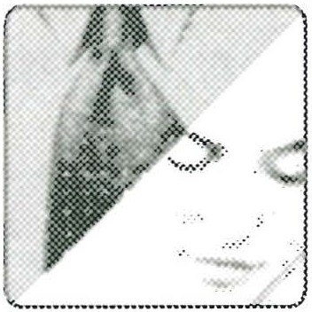

above, hold them until later in this session, when they may come up again.

0n pages 2-4 of the book are different testimonial statements by wives who have attended a Love & Respect conference, or read Emerson's books:

2

*,'[ never ever realized how important, how life-giving, respect was to my husband.* "

*'Just afew days ago, I decided to tell my husband that I respect him. It felt so awkward to say the words, but I wentfor it and the reaction was unbelievable!* . . . *I watched his de­ meanor change right before my eyes.* "

*"I wrote my husband two letters about why I respected him. I am amazed at how it has softened him in his response to me.* "

*'1 GOT IT! God granted me the power of this revelation of respecting my husband*

. . . *[it} has changed everything .* . . *my approach, my response, my relationship to God and my husband "*

From your point of view as a spouse, what do these statements say to you? 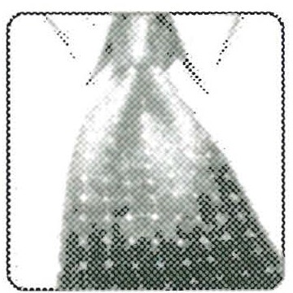 As a **husband I think:**

[ JA, a wile Ithink

12 *00* PA RT ONE-THE CRA ZY CYC LE

Compare your answers and talk about what you have covered so far. Some couples may nd i easier to talk thn .others-.do not force it; be sensitive to each other s feelings. Your study is J USt gettmg started, and you should

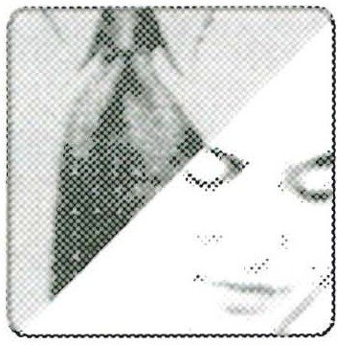

have many good sharing times as you get farther into this workbook.

3In an introduction to Part One (page 6), Emerson writes:

"I wrote this book out of desperation that was turned into inspiration. *As* a pastor, I

counseled married couples and could not solve their problems. The major problem hear, · from wives was, 'He doesn't love me.' Wives are made to love, want to love and expect love. Many husbands fail to deliver. But as I kept studying Scripture and counseling cou­ ples, I finally saw the other half of the equation. Husbands weren't saying it much, but they were thinking, *She doesn't respect me.* Husbands are made to be respected, want respect, and expect respect. Many wives fail to deliver. The result is that five out of ten marriages land in divorce court (and that includes evangelical Christians).

"As I wrestled with the problem, I finally saw a connection: without love from him, she reacts without respect; without respect from her, he reacts without love Around and around it goes. I call it the Crazy Cycle-marital craziness that has thousands of couples in its grip."

You will be learning and talking about the Crazy Cycle a lot more as this study pro­ gresses, but for now, understand that Crazy Cycles come in all shapes and sizes, as Emerson's daily mail attests. One man caught in a severe Crazy Cycle wrote:

"We were in the middle of one of our fights . . . . My wife was saying things that mad,. me fume. She had no respect for me at all. I knew she loved me but her belligerence_.., was too much. Fed up, I turned and went into my computer room. I left her scream­ ing in the kitchen."

Granted, the above letter describes a marriage with the Crazy Cycle out of control. But there are other ways to be on the Crazy Cycle or to start one. Here are three more ex­ amples, based on mail Emerson has received:

A husband and wife are looking at jewelry together while shopping. The husband points excitedly and says, "Look, honey, I think those earrings are what you're looking for!" Her condescending response: "No, they aren't! Those are yellow gold and I don't like yellow gold; I want white gold!"

SESS ION ONE *00* 13

A wife greets her husband as he comes in from work. She wants to share what hap­ pened that day while she visited a friend. He cuts her short with: "Don't bother me. Traffic was a nightmare. I just want to kick back and watch the news until dinner."

A husband and wife have had a disagreement (the same one they usually have). She wants to talk about it; he clams up. As she badgers him to share his feelings, he picks up a newspaper and is soon engrossed in the sports page.

Choose one or more of the situations reported above. What is going on? Why could the husband feel disrespected or the wife feel unloved?

Compare notes on the examples above of how the Crazy Cycle can start up (or just keep going). Ifyou don't seem to have a lot to discuss at this point,

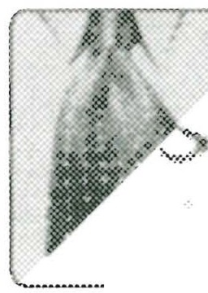

j

=. move on. You are just getting introduced to what the Crazy Cycle is and

how it affects marriages.

What is your response to the term, Crazy Cycle? Does it seem to apply to your marriage-at least some of the time?

4

YES No MAYBE

##### I think:

14 '*' PA RT ONE-THE CRA ZY CYC LE

Check any of the following that apply.

I see **the** Crazy Cycle **starting up when:**

1. My spouse appears unreasonable b. I appear unreasonable
2. My spouse doesn't make sense
3. I don't make sense
4. My spouse is harsh and/or critical

f. I am harsh and/or critical

g. My spouse is inconsiderate h. I am inconsiderate

i. We argue about sex, money, in-laws, or _

1. My spouse won't talk
2. I won't talk
   1. My spouse talks too much m. I talk too much

n. Other (describe your experience or viewpoint):

Share your answers. Take note of what each of you has checked, but do not get into a lengthy discussion at this time. The main idea is that you both recognize how either of you could start the Crazy Cycle.

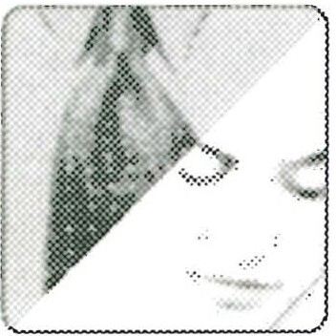

In **1** Corinthians 7:28 the apostle Paul writes: "Those who marry will face many troubles in this life, and I want to spare you this" (NIV). Did you ever stop to think that all married couples will have trouble? In other words, all married couples take a

5

SESSION ONE 0<:> 15

spin on the Crazy Cycle from time to time. Should couples conclude they have a bad marriage simply because they sometimes have troubles and things get a bit crazy? (Additional commentary is available in *Workbook* Appendix VI.)

Share ideas on what each of you thinks about Emerson's claim that there will always be "trouble" of some kind to deal with in marriage. It may be small, it may be huge, but trouble is something that does come up from

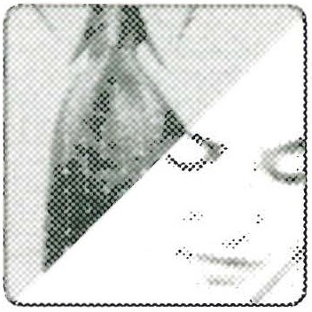

time to time.

In Chapter One, Emerson recounts his early life and first years of marriage as he and Sarah rode the Crazy Cycle. Reread the story of "The Jean Jacket 'Dis­ agreement'" (pages 9-10) and analyze what Emerson learned. What was Sarah feeling?

6

What was Emerson feeling?

Compare what you wrote down. Can either of you relate to this story? Have you had similar things happen?

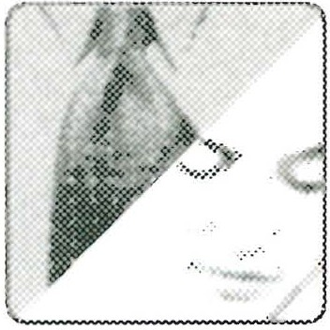

-

16 *00* PA RT ONE-TH E CRA ZY CYC LE

During an argument after attending a Bible study (book pages 10-11), Emerson responds to Sarah's criticisms by saying: "Sarah, you can be right but wrong at the

?

top of your voice." Does this statement ring a bell for you? Is your spouse ever right but wrong at the top of his/her voice? Are you ever right but wrong at the top of your voice? How does this keep the Crazy Cycle spinning?

As you discuss this question with each other, the wisest approach is not to accuse your spouse, but to confess the times when you may have been "right but wrong at the top of your voice."

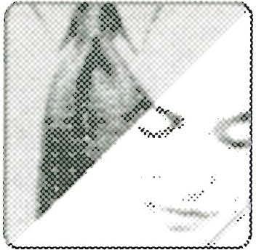

Read the story of ''And Then I Forgot Her Birthday" (book page 12). Has some­ thing like this happened in your marriage? Did you feel unloved or disrespected?

8

Did your spouse? Think back and describe what happened as you remember it.

Recalling a forgotten birthday may not make much difference to him, but it will to her. Ifa hsband is the_ one at fault, he ould o well to ap_ologize. For more on how important birthdays and anmversanes are to wives, see

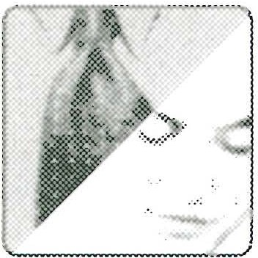

Session Eight, page 115.

SESS ION ONE C9:> 17

0n pages 13-14 Emerson describes a pattern in his marriage of "Loving Times and Spats of Ugliness." He and Sarah love each other, but they still irritate each other

9

in certain ways-even to this day. Can you relate to their experience? In what way?

This is another question where you should go easy on each other. Try to identify hat happes wen the positive times turn negative. Are certain words said? Are certam thmgs done or not done? Always remember the key



questions: Does she feel loved? Does he feel respected?

ln Song of Solomon 2: 15, the lovers resolve to "Catch the foxes . . . the little foxes that are ruining the vineyards." In other words, they don't want anything

1O

to spoil their relationship. What are some "little foxes" that threaten to spoil your mar­ riage and keep the Crazy Cycle rolling along?

Though we will have "trouble" in marriage (1 Corinthians 7:28), that doesn't mean we should assume trouble is always inevitable. Some trouble can be caused because we have not dealt with the "little foxes" that we know are there. What could you do to

18 c:9:> PA RT ONE-TH E CRA ZY CYC L E

reduce some of the crazy negativity that causes unnecessary trouble? Write down some different steps you can take to drive out the "little foxes."

Share ideas on how to go "fox hunting." Each spouse will do well to think of things he or she needs to do, not what the other spouse needs to do.



-

In "The 'Secret' Hidden in Ephesians 5:33" (book pages 14-15), Emerson ex­ plains how God helped him see the secret to defeating the Crazy Cycle. This

11

secret is in Ephesians 5:33 (NIV):

*However, each one ofyou also must love his wife as he loves himself, and the wife must respect her husband.*

In "How God Revealed the Love & Respect Connection" (book pages 15-17), Emer­ son explains how his study of Ephesians 5:33 began to show him a definite link between love and respect. He realized that a husband is to obey the command to lov even if his wife does not obey the command to respect, and a wife is to obey the corn mand to respect even if the husband does not obey the command to love. As Emerson saw it, Ephesians 5:33 didn't leave much wiggle room. A husband can't say, "I will love my wife after she respects me." Nor can a wife say, "I will respect my husband after he loves me" (see page 16). A husband's love for his wife must be unconditional, and a wife's respect for her husband must also be unconditional.

What do you think? Is there any "wiggle room" in Ephesians 5:33? Many wives believe (some with good reason) that their husbands don't deserve respect. What is Paul say­ ing to wives who may feel like this deep down? (Additional commentary available in *Workbook* Appendix VI.)

SESSION ONE 19

Keep in mind each other's comfort zone. (For example, some spouses like discussing the meaning of the Greek more than others.) The key point Emerson is making is Ephesians 5:33 dearly teaches that husbands must

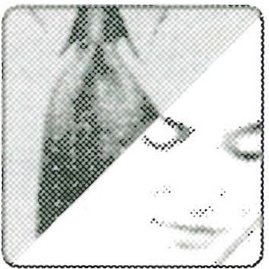

unconditionally love their wives and wives must unconditionally respect their hus­ bands. This can be new and striking information for a wife, so the husband should be sensitive to her need to process this idea over time.

For more on the concept of unconditional respect, read "Why Love & Respect Are Primary Needs" (book pages 17-19). See especially pages 18-19, which

12

give additional comment on Ephesians 5:33 and then show how 1 Peter 3: 1-2 also teaches unconditional respect for husbands. What kind of a husband is Peter talking about? How can a wife feel respect for a man who does not believe, or who is not treat­ ing her lovingly? Is she supposed to feel respect, or is Peter asking her to do something else? Write your thoughts below. (For additional interpretation of 1 Peter 3:1 and its application to husbands, see *Workbook* Appendix II.)

*/ -*

As you share answers, you may want to just touch on this question. To go into it in depth (see *Workbook* Appendix II) may be something you want to do at another time. The key point is that 1 Peter 3:1 is a cross-reference sup­

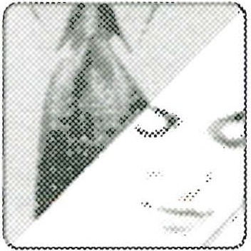

port to Ephesians 5:33. Both passages teach unconditional respect for the husband by the wife.

20 c:so PA RT ONE-TH E CR A ZY CYC LE

On page 16 of *Love & Respect,* Emerson relates that he still did not totally understand the Love & Respect Connection until God guided him to see that

13

it is a connection that can be strained or even broken. Without love she reacts with­ out respect, and without respect, he reacts without love-the Crazy Cycle.

Read pages 15-16 again to be sure you follow Emerson's reasoning. Does it make sense? Why or why not? How do his ideas apply to your marriage? Husband, do you think you understand how to love your wife? Wife, are you certain you understand how to respect your husband? What are some examples of how you believe you are de'. ing this?

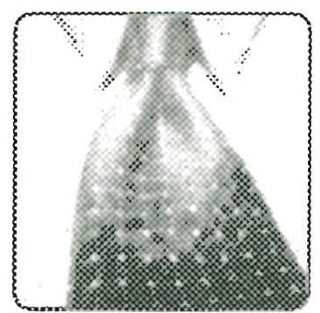 **I love my wife by:**

: JI respect my husband when I

SESS ION ONE '*' 21

You can take one of two approaches on this question:

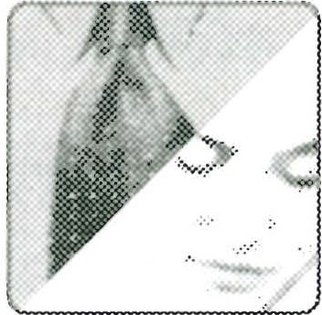

* Keep your answer to yourself at this point and use it as your personal checkpoint on how you are treating your spouse.
* Share your answer with your spouse and get his or her feedback. Try to give each other positive suggestions and encouragement whenever possible.

## _,,-...1,

**40n** page 20, Emerson describes and illus:rates the "ife-changing decision" he

* and Sarah have both made. He has decided to believe that no matter what

Sarah says or does, she does not have evil intentions. She might have a nasty or pee­ vish moment but deep in her heart she intends to do good. She may come across in a way that seems disrespectful to Emerson, but that is not her real purpose. And Sarah has decided to believe that, no matter what Emerson says or does, he does not intend, deep in his heart, ill will toward her. He may come across in an angry way, and give her a cold stare that seems unloving, but his real purpose is not to be uncaring. (See his accounts on pages 20-22 of the book concerning peppered eggs and wet towels to see how this plays out in their marriage.)

Take a few minutes to end your study of Session One by thinking and praying about a woman's deep need for love and a man's deep need for respect . Consider how the de­ cision Emerson describes on page 20 of the book applies to you. If you are studying alone, you may be in one of several situations: You may be trying to find answers for your marriage, but your spouse isn't interested in studying anything with you at this

r---oint. You would like to decide that no matter what your spouse says or does, deep down your spouse loves (or respects) you, but you aren't quite sure this is always true. In fact, at this point you may be thinking you need more time and more study of how love and respect work in a marriage. Emerson has many more insights to share, begin­ ning with Session Two, which covers why men and women are so different, and which often causes communication problems.

Talk about what this chapter has been saying to both of you. Share any "light bulb moments," questions, or concerns you may have. Perhaps you are ready to make the same decision about each other's good intentions that

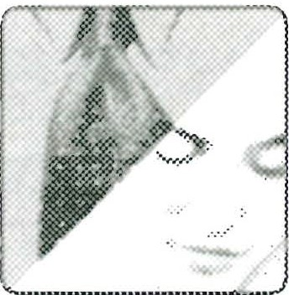

Emerson and Sarah have made (see book page 20). Perhaps one of you isn't quite ready. Wives, in particular, if your husband seems unwilling or uncomfortable about

22 PA RT ONE-THE CRA ZY CYC LE

taking this step so early in your study together, do not be critical or disrespectful. Do not rush something like this. Be willing to pray and think about it. Both of you may need more time, or more information about the Crazy Cycle and why people can't seem to slow it down. As Emerson says, there is much more he wants to tell you. In Session Two he will talk about how husbands and wives can learn to communicate, despite their differences as men and women.

A JOU RNA L OF MY JOU RN EY TO LOV E &'. RES PE CT

Every session will conclude with Emerson's meditations on foundational Scripture passages cited in *Love & Respect.* The space provided below for you to interact with his observations will allow you to create a personal journal of your journey to love and respect . By the time you finish this workbook, you'll have a permanent record of your growth and development as an individual or as a couple.

SCRIPTURE MEDITATIONS

1. "Enjoy life with the woman whom you love" (Ecclesiastes 9:9). When on the Crazy Cycle, many a husband wants to throw up his hands in defeat. Does Ecclesiastes 9:9 suggest that a husband could influence the emotional temperature of his marriage more than he might think? As a husband, what might you do for or with your wife in the next several hours that is wholesome and enjoyable-something to ignite a smile in both of you?
2. The Crazy Cycle is, indeed, "the evil of folly and the foolishness of madness" (Ecclesiastes 7:25). When the Bible speaks of "madness," it does not refer to someone who is mentally deranged . This person has a sound mind, but he or she is acting or reacting in ways that God deems foolish, unfruitful, even "crazy." Think about it: how crazy is it for a husband to react in unloving ways when feeling disrespected? How crazy is it for a wife to react in disrespectful ways when feeling unloved? You might say, "But it's natural to react sometimes in an unloving or disrespectful way. " Natural, yes, but effective, no. What do unloving or disrespectful reactions do to the spirit of a spouse?

SESS ION ONE 0l:> 23

1. In Ephesians 5:33, Paul writes: "Each one of you also must love his wife as he loves himself, and the wife must respect her husband" (NIV). Because Ephesians 5 contains what is considered the greatest treatise in the Bible on marriage , it is safe to say that Ephesians 5:33 is, in effect, God's "last word" to us on this subject. But God's last word on marriage won't help you if it isn't heard . Do you believe that if, as a couple, you apply love and respect to your marriage you will experience marriage in the way God intended? Do you believe love and respect will guide the two of you in respond­ ing correctly to troubles that are bound to come to your marriage? Do you believe that t the end of your life, after living out love and respect, you will be able to pray: Thank You, Lord, for showing me Your simple plan for marriage"? (Put down your honest thoughts here. Ifyou have any doubts write them out, then give them to God in prayer.)

**My current thoughts about our marriage:**

**SESSI ON Two**

In preparation for this session, read Chapter Two in *Love & Respect,* "To Communi cate, Decipher the Code." The following questions are for use in individual study, *or"* study by a husband and wife together. Remember to answer all unmarked questions first, then answer questions marked by the male or female icon (whichever applies to you). Finally, answer the questions with the couple icon, if you're studying with your mate. (Suggestions for using this workbook with a group are in *Workbook* Appendix I, page 201.)

### Qu esti ons for Chapter Two

On page 25, Emerson opens Chapter Two by asserting that husbands and wives communicate in "code" and must learn how to decipher the messages they send

1

each other. What do you think?

How often does your spouse seem to communicate in a "code" that is hard to decipher or understand?

CONSTANTLY OFTEN Now AND THEN SELDOM *.. )*

Discuss this question gently and sensitively, particularly if your answers fall in the "constantly" or "often" range. Ifyou do have a communication problem, this session is designed to get you talking about it and learning how to work



on it. Guard against getting into an argument about "who communicates the worst."

SEss10 N Two *00* 25

Read the story of the "Tenth Anniversary Card" that turned out to be a birthday card (book pages 25-27.) When the wife responded in anger, what coded message

2

was she sending to her husband? What coded message was he sending to his wife when he responded defensively by saying, "I made an honest mistake; give me a break"? How did they start the evening anticipating a wonderful tenth anniversary and wind up on the Crazy Cycle?

* + · Compare notes with your spouse (and with Emerson's additional commen­



o- . tary on Question 7 found in *Workbook* Appendix VI). Talk about how the

_ '._ couple wound up on the Crazy Cycle on a night when they should have been celebrating.

*('3*Read the story that starts under the heading, ''All You Want Me for Is Sex!" (book pages 27-29). What message was the wife sending in code as she reeled off a bar­

rage of problems, appointments, and assignments the minute her husband returned from his trip? What message was the husband sending in code when he said sarcasti­ cally, "Great to see you after a week''?

26 PA RT ONE-THE CR A ZY CYCLE

Later, when this same husband and wife go to bed after their exhausting day, what coded messages do they send each other? What mistakes do they make in doing

4

so? Why can't either spouse decipher the other's code? How did they get on the Crazy Cycle?

Compare your answers to Questions 3 and 4. If you aren't sure you have ientified the encoded me.ssages. corredy, hold them for discussion in Ques­ tion 7, where Emerson will review this story and make comments on what

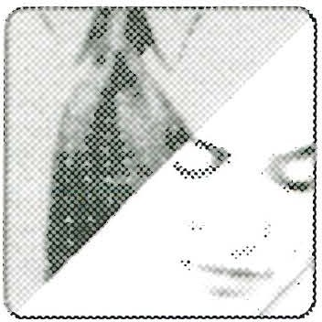

the encoded messages meant.

Under "Craziness-Just Keep Flipping the Light Switch" (book page 29), Emerson compares the Crazy Cycle to mindlessly flipping a light switch over and over when

5

the light won't come on. Instead of figuring out the problem, you just keep flippin\,,J that switch. Emerson's point is simple: "Craziness happens when we keep doing the same things over and over with the same ill effect." What things do you or your spouse do over and over that help start you both on the Crazy Cycle?

SESSION Two *00* 27

Go easy with each other when discussing this question. Confess your faults, not your spouse's. Try to have some fun with this, and don't call each other "crazy." The truth is, any couple can get on the Crazy Cycle together, and

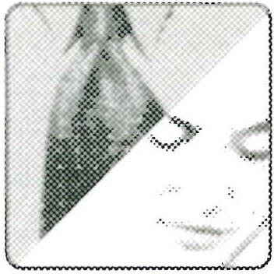

you must work together to slow it down and stop it.

In "Why Do Couples Communicate in Code?" (book page 30), Emerson para­ phrases a well-known explanation of why and how we send messages in code and

6

,.,--ion't communicate: "What I say is not what you hear, and what you think you heard is not what I meant at all." Read the story about Emerson and Sarah almost getting into a serious argument about who was listening to what on the radio. How did Emerson finally break the codes they were sending and stop the problem from escalating?

You can learn a lot about communicating as you discuss your answers to this question. The way Emerson stopped the Crazy Cycle from spinning was to realize he was not being clear (and not very loving either). Once he



*( rake* the pattern of miscommunication, he and Sarah were able to understand each other and prevent sparks from becoming a fire.

Read the section titled, "When the Issue Isn't the Issue" (book pages 31-32). What was the real issue when the husband gave the wife the wrong kind of greeting card?

?

28 *00* PA RT ONE-THE CR A ZY CYC LE

What was the real issue as the businessman's wife turned him down when he wanted sex?

Compare your answers. Did you agree that the real issue in these stories, as it usually is in all marital arguments or ghts, is love and resect? She doesn't feel loved or she desperately needs a kiss or a hug-somethmg to assure her



she is loved. And he doesn't feel respected. He needs to feel he is appreciated and that he is someone his wife looks up to, not down upon. For interpretation of the encoded mes­ sages the spouses were sending each other in each story, see additional commentary on Question 7 in *Workbook* Appendix VI.

Are you beginning to see the importance of "decoding" each other when one or both of you sounds irritated, angry, or sarcastic? No spouse can de­ code his or her mate perfectly, but it is vital to understand that the need to

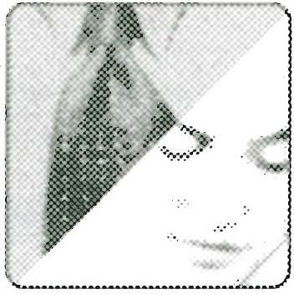

decode is always there, and the more you both work on doing it, the better your com- munication will be. *)*

In "We're as Different as Pink and Blue" (book pages 32-35), how is male-female communication described? According to Emerson, women see the world through

8

sunglasses and hear with hearing aids. Men see the world through sunglasses and hear with hearing aids. Why is it important to understand these differences? How could understanding their pink and blue perspectives have helped the couple whose tenth anniversary was spoiled by the wrong kind of greeting card or the couple who reconnected so badly after his week on the road?

SEss 10N ·1wo *00* 29

Compare your answers, as well as your respective understandings of the

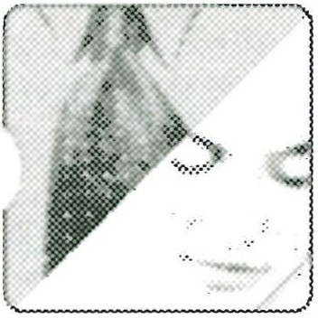

,_., pink. and blue anlogy. This question is eally a contiuation of Question 7.

Obv10usly, the pmk and blue perspectives of the wife and husband have everything to do with the kinds of codes they send and the decoding that needs to be done. Try working together to re-create each story to make it come out with a happy ending, or at least with the Crazy Cycle slowing down and even stopping. In either story, what might the husband have said or done that would have felt more loving to the wife? What might the wife have said or done that would have felt more respectful to the husband?

Emerson constantly receives letters from spouses who finally "get it" concerning the deep need in wives for love and the deep need in husbands for respect. Following is one such letter, from a wife, who came to see clearly the difference be-

9

tween "pm. k" and "blue)) :

*,-l readyour book this week and I have been convicted. I have always felt that ifI just loved*

*,ay husband enough, he would come around and be the kind of man myfather was. Then Godproceeded to show me the many ways I have been disrespectful towards my husband­ and myfather!*

*I now see that most of the arguments have been started by me, in my misunderstanding of the way my husband thinks. I have been arrogant and self righteous in my misguided at­ tempts at communication in hopes of bringing us together. What afool I've been! It sounds so dumb when I write it down!*

*I wrote him a letter today in apology and my desire to change. He called to say, "It's okay, it was nothing!" What a man!*

30 *00* PA RT ONE-TH E CR A ZY CYCLE

*I never saw my disrespect as disobedience to Christ before. That really hurt. I know now what a grievous sin it is and I pray for grace and help to change. Thank you for this liber­ ating truth.*

*Grace and peace to you and may I see and hear in blue!*

What has this wife understood? What does she mean when she says: ". . . may I hear and see in blue!"?

Here's another letter, from a husband who also finally "got it." He and his wife had started going to a counselor before they attended a Love & Respect Conference, and they continued to go afterward as they tried to apply love and respect principles. He writes:

*Recently, I hadforgotten to do somethingfor my wife. She expressed hurt and anger toward me at the next [counseling] session. Our counselor concluded that I have not been "hear­ ing" her because I react in a "defensive" way to her comments, and this has hurt her and caused her to shut down. He has challenged me to learn her "language" [pink} so that will "hear" her. Subsequently, she will melt and then respond with respect.* . . . '---

*I accept my divine command to unconditionally love my wife through any technique that works. I still dofall into the Crazy Cycle, but I try my best to stay off of it. I do intend to sign upfor "pink language lessons.* "

What has this husband understood? What does he mean when he says he wants to "sign up for 'pink language' lessons"?

SEss10 N 1wo *00* 31

You may wish to discuss one or both of these letters at length. In each case the spouse writing the letter has gotten the point: "pink" and "blue" must

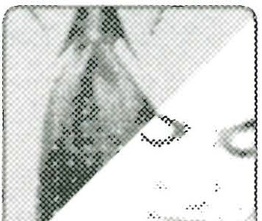

*/ -* try to see and hear in the other color. When pink or blue sees it only one way, the Crazy Cycle will keep on spinning. Ifboth spouses are agreed, now would be a good time to pledge to each other respectively:

As a wife, I want to see and hear in blue a lot more. As a husband, I want to see and hear in pink a lot more.

What does Emerson mean near the bottom of book page 34 when he sums up the wrong anniversary card debade by saying: ". . . and so two essentially good­

1O

willed people wound up spinning on the Crazy Cycle with no due about how to slow it down or stop it"? How does he define *good-willed* on the top of page 35? Put his def­ inition in your own words beginning with: "My spouse . . ."

32 *c:50* PART ONE-TH E CRA ZY CYC L E

Compare your definitions of *good-willed.* This term will be popping up again and again in this study. The key point to remember is that no matter how nasty, irritating, or unreasonable your good-willed spouse is, he or she



does not mean to hurt you in the ultimate, long-range sense. Oh, there may be some intent to hurt on a short-range basis, but this is not what your spouse really wants. What every spouse wants is love for her and respect for him. (For more on the con­ cept of "good will" and questions like: "How can a sinful person have good will?" go to <http://loveandrespect.com/> pearl/.)

In "Scientific Research Confirms the Centrality of Love & Respect" (book pages 35-37), read the conclusions of marriage research expert John Gottman,

11

who studied two thousand couples who had been married twenty to forty years to the same partner. What single factor stood out as a reason they stayed together for the long term?

1. having enough money
2. attending church regularly
3. a loving, respectful tone to their conversations d. spending enough time together

Gottman adds that contempt is "perhaps the most corrosive force in marriage." Do you think he is right?

Compare your answers. Talk about how contempt can hurt and how a lov­ ing, respectful tone can heal.

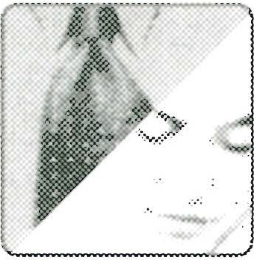

-

S Ess10N 1\vo *00* 33

12

Read the analogy described under "You're Stepping on My Air Hose!" (book pages 37-38). Emerson pictures the wife with an air hose leading to a big tank

labeled "Love." What happens when the husband does something to "step on her air hose"?

Which of the following statements are examples of how a husband can step on his wife's air hose?

* 1. 'TH do the dishes, honey. You had a rough day with the kids."
  2. "Can't you get that kid to be quiet? I'm trying to get a few minutes rest."
  3. "I know we planned to spend some time tonight talking, but the guys want to come over to play cards."
  4. "Sorry I couldn't call sooner. The meeting ran late, but I should be home about 6:30."

Compare your answers. These choices should be "no brainers'' for both of you, but use this question to get into your own discussion of how a hus­ band can step on his wife's air hose. (Try not to step on each other's air hose

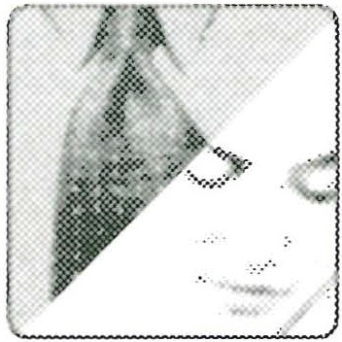

as you talk together.)

,.,.--

On book pages 37-38, Emerson continues his illustration by picturing the hus­ band with an air hose leading to a big tank labeled "Respect." What happens if

13

his wife happens to "step on his air hose"?

34 *00* PA RT ONE-TH E CRA ZY CYC LE

"Which of the following statements are examples of how a wife can step on her hus­ band's air hose?

a "The bills keep piling up. Why can't you bring in more money?"

1. "Honey, I know things are tight, and I'm so thankful that you get out there every day, working hard to make a way for us."
2. "Jane's husband doesn't lie around watching so much TV"
3. 'Tm so grateful you like being home and being available when I need help."

You should find the right choices fairly easy to identify, bu t use the ques tion to get into a discussion of what happens in your home. How can you _/ step on each other's air hose, perhaps in all innocence?



--

--

In "Men Hear Criticism as Contempt; Women Feel Silence as Hostility" (book pages 38-40), Emerson gives valuable insight on just how pink and blue sun­

14

glasses and hearing aids can affect a marriage. List at least three statements or phrases that stand out for you, from your pink or blue point of view.

1.

2.

3.

SESS ION Two *eso* 35

Compare notes on what you find. Note that Emerson observes that spouses may have good will (they intend no evil toward each other), but because they don't decipher each other's code, she sees only his failure to love and

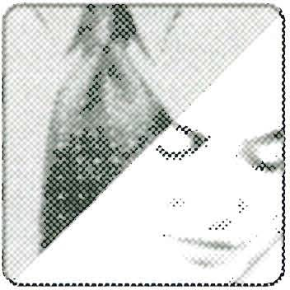

he sees only her failure to respect. They lash out and the Crazy Cycle continues to spin! Talk about how to decipher each other's codes, how to slow and stop the Crazy Cycle. (For more ideas, see *Love & Respect* Appendix A, pages 305-7.)

**15**The following is a letter from a wife who describes her life with her husband on the Crazy Cycle. As you read it, make notes on the following: Who is step­

ping on whose air hose and why? What starts this Crazy Cycle? What keeps it going?

*We have been marriedfor a long time* . . . . *We have difficult and challenging jobs and he feels that if I want to discuss something with him, somehow I think I know more than he does. I have never been a shrinking violet and the thing my husband hates about me is what my boss loves about me. I can be very aggressive and I get things done. Should I keep*

*my mouth shut? It's getting worse because we don't seem to be able to come to any kind of agreement, which is distressing at the very least. I am losing hope because we don't ever seem to get anywhere. I try to talk and he stonewalls me; he tries to talk and I stonewall him. It goes nowhere.*

**My notes:**

Talk about what you have noted in the letter above. How does the wife's "Type A Personality" step on her husband's air hose? What is his basic way of fighting back that steps on her air hose? What does their "he stonewalls

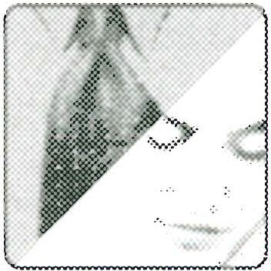

me, I stonewall him" routine tell you about this couple?

36 *OSo* PA RT ONE-THE CRA ZY CYC LE

0n book page 40 Emerson gives the secret to at least start decoding your spouse's messages: "Whenever a wife is complaining, criticizing, or crying, she

16

is sending her encoded message: 'I want your love!' And whenever a husband is speak­ ing harshly or sometimes not speaking at all, he is sending his encoded message: 'I want your respect."'

How well do you decode your wife's complaints? Though not all of her complaints are cries for love (she can just be having a "bad hair day"), it helps to think first that her complaint might be rooted in her cry for love:_;

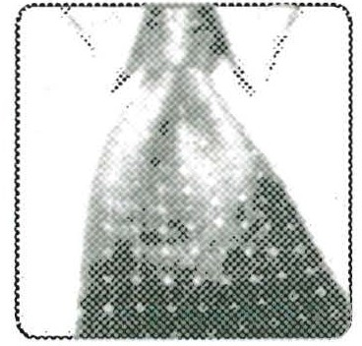

Describe a time when you heard her cry for love underneath her complaint and re­ sponded lovingly. (If you can't think of any, just write your thoughts about how will­ ing you are to listen better and decode her complaints.)

To complete this exercise, fill in the following: "The next time my wife complains or criticizes I will show her love by . . ."

SESSION Two *c:so* 37

LJ

How well do you decode your husband's actions or words when he needs respect? Silence or harshness are not always cries for respect, but they can be. Sometimes pride, or the inability to verbalize his need for respect can

keep the need covered. Never forget that his "Respect Tank" is there and that you could be stepping on his air hose. Can you think of any times recently when you heard his cry for respect underneath his silence or harshness? (If you can't, just write your honest thoughts about how willing you are to decode his behavior and try to show respect.)

To complete this exercise, fill in the following: "The next time my husband appears unloving or harsh, I will show him respect by . . ."

38 0l:J PA RT ONE-TH E CRA ZY CYC LE

Go slowly as you compare what you have written. This could be sensitive, but the benfits ar well worth it. One ara to explore is how the messaes one spouse is sendmg another could be misread. For example, when a wife

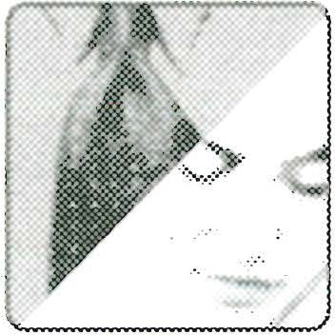

complains or criticizes, it's possible that she is frustrated about something unknown to the husband. She is not necessarily feeling a husband's lack of love. Of course, it still doesn't hurt if a husband reaches out with a touch or a hug to say, "It's okay, I'm still here for you." On the other hand, a husband's lack oflove can also be hard to read. Sometimes the "big, dumb buck" is not looking for respect; he's just being selfish, un­ aware, or ignorant of how to treat his wife. A good approach for both husbands and

wives is in *Love & Respect* Appendix A, under "To communicate feelings . . ." (book ,/

page 306). Spouses should never say, "You're being unloving," or "You're being dis­ respectful." As calmly as possible, she can say, "That felt unloving," or he can say, "That felt disrespectful." Then go on from there as explained on page 306.

As you complete your personal study of Session Two, take some time to think and pray about the messages you may be sending your spouse in code (and vice

17

versa). And as you pray, ask yourself some basic questions: when I see the spirit of my spouse deflating, do I understand that the issue is never the real issue, which is a lack of love and respect? Do I grasp the importance of "pink" and "blue"-how different my mate and I are? Am I fully aware of my "air hose" and how it can be stepped on? Am I fully aware of how I might be stepping on my spouse's "air hose"?

SEss 10N 'lwo *c:so* 39

Ifnecessary, review book pages 31-35 and pages 37-40. These ideas are simply put, but they are profound. How well you embrace and practice them will have everything to do with how well you play your part in stopping, or at least slowing, the Crazy Cycle.

Talk about what this chapter has been saying to both of you. Share any "light bulb moments," questions, or diffeing prcptions. Write dow_n ho well each of you responds to the followmg prmoples or concepts m this



- hapter (use a scale of 1-10, with 10 meaning "totally get it," as one way to measure

your responses):

The issue at hand may not be the real issue.

Pink and Blue are very different.

Each of us has an air hose that can be stepped on by the other.

40 '*' PA RT ONE-THE CR A ZY CYC LE

Her complaints can mean, "Please come across more lovingly!"

His withdrawal can mean, "Please come across more respectfully!"

Although Emerson's word pictures (pink and blue, air hose) are playful, they contain vital and practical truths. The better you understand and actually practice them, the better you will communicate with each other. Be aware that it may sound simple, but

it is not. In Session Three, based on Chapters Three and Four of the book, Emerso, ,/ will explain why.

A JouRNAL OF MY JouRNEY

TO LOV E AND RESPECT

As part of your journal, every session includes a study of foundational scripture pas­ sages quoted in the margins or text of the book. As you interact with Emerson's med-

SESSION Two *c:so* 41

itations below, make notes as part of your journal. There is additional space at the end to record your current thoughts about your marriage and the progress you hope to make with this study.

SCRIPTURE MEDITATIONS

1. When counseling couples I often quote to them James 4: 1: "What causes fights and quarrels among you?" (Nrv). I point out that the apostle James wants each of us to evaluate why he or she is having conflicts-particularly if we are married. James con-

-inues: "You want something, but don't get it" Qames 4:2 NIV). What happens when a spouse does not get love or respect? As a wife, if you feel unloved, what do you do to try to get your husband's love? Do any of these words or actions sometimes lead to quarrels? As a husband, if you feel disrespected, what do you do to get your wife's respect? Do unloving words or actions (or just stonewalling her) help? Evaluate what you have been doing to this point while on the Crazy Cycle. How effective is fighting and quarreling to get what you want?

1. Runaway divorce statistics reveal that ". . . insanity is in their hearts . . ." (Ecclesiastes 9:3). As a wife, when you do disrespectful things in a misguided attempt to motivate your husband's love, has it ever occurred to you that this is a little bit crazy? How often each week do you go a bit "insane" in an effort to get your husband to love you more? As a husband, when you do unloving things to make your wife respect you more, does it ever occur to you, "I am acting a little nuts here"? How many times this past week did you say to yourself (consciously or unconsciously), "I am not going to show love to that woman until she starts respecting me more"? Ifyou both continue

*1-* ith this sort of "insanity," how likely is it that you could be pushing your marriage

over the edge? How long will it be before you become a divorce statistic?

1. What can happen when a husband tries to obey a command from God's heart? In Ephesians 5:33, Paul is not making a mere suggestion when he writes, ". . . each one of you also must love his wife as he loves himself " (NIV). A husband who took this verse seriously wrote to tell me, "The information God gave you is working all over in my life. I have seen the glow in [my wife's] eyes when I apply it and the defeat [and] the despair . . . when I fail to practice the principles you are trying to teach me through your material and God's word." Husband, what is Ephesians 5:33a for you? A com­ mand? Or a "suggestion"? Wife, read Ephesians 5:33b, which tells you to respect your

42 *C60* PA RT ONE-TH E CRA ZY CYC LE

husband. For you, is this a dear command , or a suggestion you can follow if he "earns" your respect?

**My current thoughts about our marriage:**

# SE SSI ON TH RE E

Jn preparation for this session, read Chapter Three, "Why She Won't Respect; Why

-Ie Won't Love" and Chapter Four, "What Men Fear Most Will Keep the Crazy Cycle Spinning." The following questions are for individual study, or study by husband and wife together. Remember to answer all unmarked questions first, then answer questions marked by the male or female icon (whichever applies to you). Finally, answer the ques­ tions with the couple icon, if you're studying with your mate. (Suggestions for anyone planning to use this study with a small group can be found in *Workbook* Appendix I, page 201.)

### Qu esti ons for Chapter Th ree

So far you have been introduced to the Love and Respect Connection and the Crazy Cycle. You have learned about "pink" and "blue" and differences between men and women. You know how to be more careful about stepping on your spouse's air hose. You understand the dynamics of how the Crazy Cycle can affect a marriage: When she

,,-feels unloved, she can react in ways that feel disrespectful to him. When he feels dis­

_ espected, he can react in ways that feel unloving to her. And around and around they go. Nobody wants to be on the Crazy Cycle, even for a short time. Some couples, un­ fortunately, have been on it for years. Getting off and staying off is not as easy as you might think. In the two chapters of *Love &Respect* covered in this session, you will dig a little deeper into why wives find it hard to respect and why husbands in turn won't

love.

I

No one has ever expressed the Crazy Cycle dilemma better than the husband whose letter appears on pages 41-42 of *Love & Respect.* Read his letter carefully. What do you hear him saying from deep within his soul? What is his wife saying about him and their marriage? What do you think it does to this man to hear, "You're not the man I

thought you were"?

44 0<? PA RT ONE-TH E CRA ZY CYC LE

Compare notes on how you think a husband might feel when told, "You're not the man I thought you were." Then, to add a "fair and balanced" ton1:- J to your discussion, also consider this question: "What do you think it does



to a woman when her husband angrily delivers his own message, which blames her for their problems?"

Read "Unconditional Respect-An Oxymoron?" (book pages 42-44). In his many years of counseling, Emerson has often heard women say they have never heard the

2

two words "unconditional respect" put together in the context of a relationship (pag'--../ 43). To these women unconditional respect sounds like an oxymoron (a term created by putting together two words that appear to be incongruous or contradictory). Why do you think so many women feel this way? Choose from the following ideas, or write your own:

1. They think respect is something a husband has to earn.

b. They think husbands are so unloving, they don't deserve respect.

1. They think that giving a husband unconditional respect is giving him license to do anything he wants.
2. I think:

SESS ION THR EE *00* 45

*I*

Discuss the answers you chose above. You may also want to tackle questions like the following: why does telling a husband he has to earn his wife's re­ spect put him in a lose-lose situation? What is the difference between show­

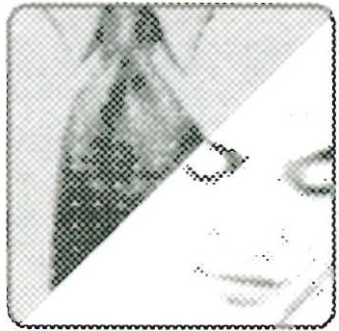

ing respect and feeling respect? Is it okay for a wife to show respect, even though she doesn't feel respect? What do facial expressions and tone of voice have to do with how a wife shows her husband unconditional respect?

In "It All Goes Back to Pink and Blue" (book page 45), a wife is quoted: "We think so differently, I don't even relate to what he considers respect (or the lack of it)." How could this wife adjust her pink sunglasses and pink hearing aids so she might be­ gin to understand her husband's need for respect? Would it help if she remembered her husband's need for respect is just as great as her need for love? At the same time, how could this woman's husband adjust his blue sunglasses and hearing aids? How crucial is it that he respond patiently to his wife's struggle with the new idea of "un­ conditional respect" for him, especially if he has done things that deeply hurt her?

3

Write your thoughts here and on the next page:

46 CS::> PA RT ONE-TH E CR A ZY CYC LE

Talk about your respective perceptions of "respect." What positive things could happen if each of you made a slight adjustment?

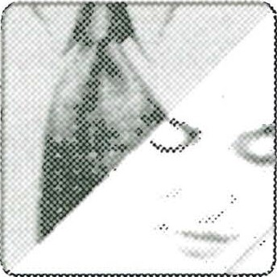

,

Continuing on book page 45, Emerson admits that for years as a pastor he went along with the cultural emphasis on unconditional love by the husband for the wife as the key to a good marriage . When he switched his message and started giving equal weight to unconditional respect for husbands, he got a mixed reception. One

4

women's group actually fired him after he taught two sessions! They wanted someow· to speak on "How to Love Your Husband ." What they failed to see was that the way_./ for a wife to fully love her husband is to respect him in ways that are meaningful to him. What do you think this might entail? How can a woman respect her husband in meaningful ways? When a wife attempts to show this kind of respect, what can a hus­ band do in response to show his appreciation? Put your thoughts in writing:

SESSION THREE 0':> 47

*r la,* Share what you have written. If either or both of you are struggling a bit

* · with the oncept of a man's deep need for respct, be sensiive o each other.

- - It also might help to use some of the suggestions under Things to say to lighten up the relationship," *Love & Respect* Appendix A, page 307.

In "Respect Is a Man's Deepest Value" (book pages 49-52), Emerson reports on a national survey in which 400 men were asked which they could endure better:

5

(a) to be left alone and unloved in the world, or (b) to feel inadequate and disrespected by everyone. Seventy-four percent said they would prefer being left alone and unloved over feeling inadequate and disrespected (see page 49).

Would you have been among the 74 percent who believed the more negative experience would be feeling inadequate and disrespected? Why or why not?

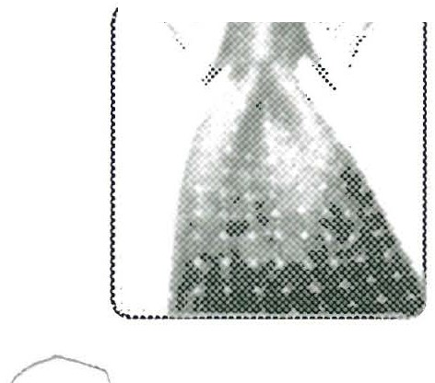



48 *CbO* PA RT ONE-THE CRA ZY CYC LE

Compare your answers and also talk about Emerson's analogy (bottom of book page 49) in which he compares love and respect to food and water. D1 you agree with his statement, "For men, love is like food, and respect is like *_ J*



water"? Iflove is like food (important) and respect is like water (even more important), what does this suggest for your marriage?

Emerson is often asked if there is any passage in Scripture where men are in­ structed to respect their wives as well as love them. Under "Husbands Are to Value Wives as Equals" (book pages 52-54), he cites 1 Peter 3:7, where Peter tells the hus­ band to show his wife honor as ". . . a fellow heir of the grace of life." How doe

6

Emerson interpret this phrase (see last paragraph, page 52)? How does Galatians 3:2b---./ teach the same idea?

S ESSION THREE *00* 49

Discuss the concept that although husband and wife are very different, as male and female they are equal in the eyes of God (see Galatians 3:28).



How might a husband appear to forget this equality and unintentionally come across to his wife in a condescending manner? What does his wife feel during such moments? What practical things can a husband do to show he values his wife as his equal?

0n book page 53 Emerson develops the concept that women are to be first in im­ portance, while men are to be first among equals. As you think about how com­

7

fortable you are with these "firsts," consider these questions:

Do you think your wife longs to be first in importance because she is a prima donna or because she wants to respond, give, and serve?

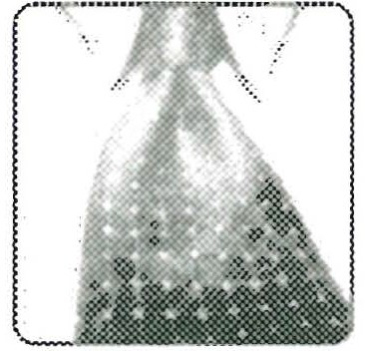

Do most husbands want to be seen as first among equals because they be­ lieve it is their "right" to dominate, or because they believe it is their respon­ sibility to lead, protect, and even die for their family?



50 *00* PA RT ONE-TH E CR A ZY CYC LE

Compare your answers. In the second paragraph, book page 54, Emerson states: "When he honrs her s first in iportance nd she. repects him as first among equals, their marriage works. Do you think he is nght? Are you

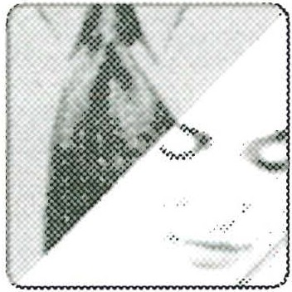

willing to make this a major goal in your marriage? Is your spouse?

Under "Husbands: Do Not Say, 'I Told You So!'" (book page 54), Emerson cau­ tions husbands that the concept of unconditional respect can be a "huge piece of information" for a wife to process. Why should a husband *never* say, "I told you so!"

8

or try to use unconditional respect as a weapon?

Talk about what each of you is thinking and feeling. Obviously, a wise hus_:­ band will not "rub it in" if his wife is struggling to process what Scriptur..J teaches. Also read together on book page 55 the two letters from husbands



after they attended a Love and Respect Conference. What insights did each man receive, and how did this information affect his attitude toward his wife?

SESS ION THREE *00* 51

#### Qu esti on s for Chapte r Fo u r

As he starts Chapter Four on page 57 of the book, Emerson discusses a power­ ful factor that can keep the Crazy Cycle spinning: the male fear of criticism, and especially contempt. Men may look powerful and impervious to their wives' words, but underneath they are very vulnerable. The male species is often labeled as the one that likes to get into fights, and as Emerson pointed out in Chapter Three, it is the male who primarily responds to the call to war, to protect home and family.

9

Nonetheless, males do not handle conflict with their wives well at all when they feel Jisrespected (see survey questions results, page 58). Emerson writes: "Men know deep down that their wives love them, but they are not at all sure that their wives respect them." Are men being overly sensitive or perhaps a bit arrogant by being so concerned about being respected? Write down what you honestly think:

Share what you wrote with each other. Also read together Emerson's idea that among men there is an "honor code"-from boyhood men learn there are certain things men just don't say to one another. A woman will talk to

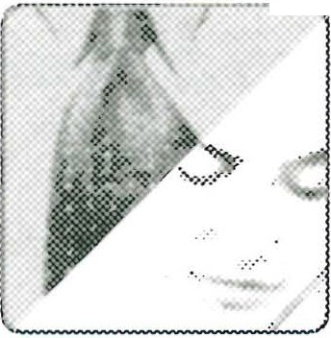

-

*r* husband in the home in a way that a man would never talk to him. "He can't believe she can be so belligerent, so disrespectful" (bottom of book page 59). Does your expe­ rience as a husband bear this out? As a wife, do you think you ever talk to your hus­ band in a "belligerent" manner?

52 *00* PA RT ONE-TH E CR A ZY CYCLE

1O

Read ''Are You a Criticizer or a Stonewaller?" (book pages 60-61), then answer these questions: Who is the criticizer and who is the stonewaller in your mar­

riage? Why do men (as a rule) stonewall their wives?

This can be a delicate question for a husband and wife to discuss, so go easy on each other. Be sure you both define *stonewalling* the same way. Simply put, stonewalling is refusing to talk, period.

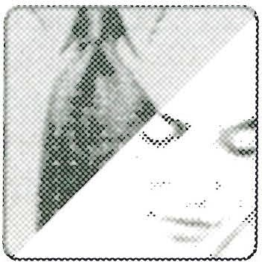

On book pages 61-62, "How Women Deal with Conflict Between Them­ selves" describes a typical female approach to conflict with another female, like

11

a best girlfriend. Why do a wife's complaints and criticisms, expressed during conflicts with her husband, seldom result in shared sorrow, hugs, and even laughter as often happens with a best girlfriend? Choose from one of the ideas below, then add your own thoughts:

1. Husbands are too proud to admit they are wrong.
2. Husbands don't see their wives' deeper goal of reconciliation.
3. Husbands clam up because ongoing criticism feels like contempt.
4. Wives are more critical and judgmental of their husbands than of their girlfriends.
5. I think:

SESSIO N TH REE *OSo* 53

Share your answers. How do your perceptions differ? Do you see examples of "pink'' (her viewpoint) and "blue" (his viewpoint)? Why is it obviously not a good idea for a wife to deal with her husband in the same way she

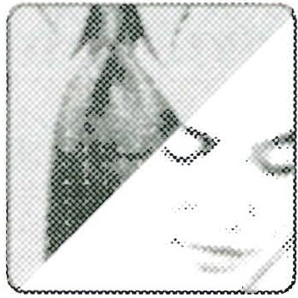

deals with a best girlfriend?

In ''A Wife's Self-Image May Depend on Her Husband's Approval" (book pages

12

62-63), read the letter from the wife who realizes that negative confrontation (being way too demanding and critical of her husband) doesn't work. As you analyze her confession of mistakes, what would you suggest that might work much better?

/- ......

Compare your findings on the wife's letter. Discussing this question can be a real opportunity to work together positively to understand how Love and Respect principles apply to your marriage. Can both of you fill in the Crazy



Cycle maxim below, without going to the diagram on page 5 of *Love & Respect?*

**Without**-------she reacts **without** -------

**and**

**Without** he reacts **without _**

54 *c:so* PA RT ONE-THE CRA ZY CYCLE

13

Read "A Wife's Scolding Can Start the Crazy Cycle" (book pages 63-66). Why do wives often make the innocent mistake of scolding (or mothering) their

husbands?

Talk about any "scolding" that might be going on in your marriage. Husband, be gentle in describing what you might think is scolding. Wife, try not to be defensive if he labels what you think are "constructive com­

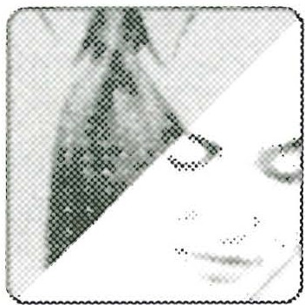

ments" as scolding. How can the male need for unconditional respect cause him to interpret certain comments by his wife as "scolding"? (For ideas on what the wife can do, see Question 14 below.)

To avoid sounding like she is scolding, which of the following questions is the best one for a wife to ask herself as she interacts with her husband?

14

1. Is what I am about to say/do going to let him know that we are equals and he cannot treat me as "lesser than"?
2. Is what I am about to say/do going to come across as loving or unloving?
3. Is what I am about to say/do going to come across as respectful or dis­ respectful?

SESSION THREE *cso* 55

Talk about which response on the previous page is the best question for a wife to ask. Then identify the best question for a husband to ask himself before interacting with his wife. (See *Love &Respect* Appendix A, page 305,

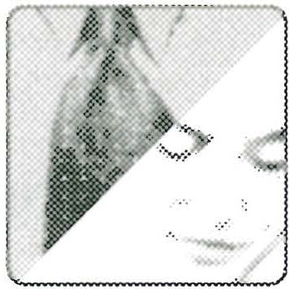

under ''Always Ask Yourself." Also go over the "Taboos" on page 307.)

On book page 66 is an account of how one woman asked her husband: "Do you want me to tell you I love you or respect you?" What was his answer?

15

At this point in the study, are you comfortable with asking your husband this same question? YES No NOT SURE

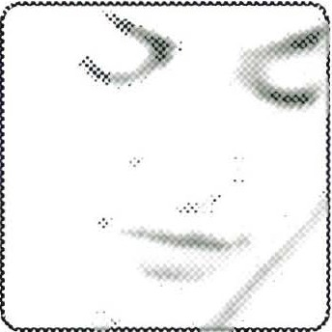

_..

What would be your answer? LOVE RESPECT _

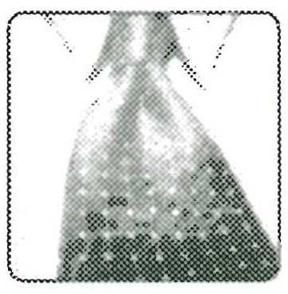

Ifyou feel comfortable doing so, share your answers and feelings. If a hus­ band answers "Respect," he should try to help his wife understand without shaming her. Put a "U" next to any statements below that would help a wife

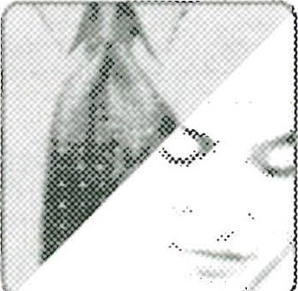

r .. Jnderstand and a "D" next to any statements that would put her on the defensive.

The reason I am so unloving is because you are so disrespectful.

I'm sure you love me, but I don't always have assurance you respect me.

I know you don't intend to be disrespectful, but sometimes you come across as disrespectful. At those moments I know I should love you anyway, but I don't know how and it's safer to stonewall.

Ifyou would just meet my need for respect, this marriage would be great. I couldn't care less about your love; just give me respect.

I know you often feel I don't deserve respect, and you're right. But I need you to respect who I am deep down, even though on the surface I'm some­ body neither one of us likes at times.

56 *c:>a* PA RT ONE-TH E CR A ZY CYC LE

In "So That's It . . . I Need Respect!" (book pages 67-69), analyze the letter on page 68 from a wife whose husband strayed into an affair. Without excusing

16

the husband's wrongdoing, what were some reasons he strayed? What do these reasons suggest about ways to respect a husband?

Discuss the contents of the letter. As a wife you may be tempted to dismiss its many valuable tips beca_use an adulteres is described. as using hr wiles to seduce the husband. This would be a mistake. What is wrong with see­

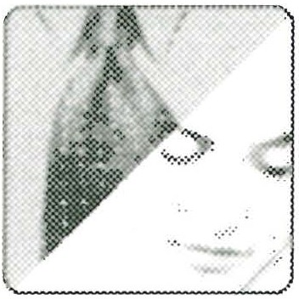

ing your husband as handsome, witry, and intelligent? Obviously all this can be over­ done, but there are suggestions here for how a wife can respect her husband and give his ego a respectful, but not phony, boost. At the same time, there is a warning here for both spouses. A wife may not be tempted in the same way her husband can be tempted, but she is vulnerable nonetheless. The wise husband pays attention to his wife's vulnerabilities and never ignores or belittles them. Many a wife has been drawn into an affair because she felt lonely and unloved. The best way to protect your mar- riage from an affair is love and respect-love for her, respect for him. _ ,

Read the section, ''All This Should Be Obvious, Right?" (book pages 69-71).

17

How true does the following statement at the very bottom of page 69 sound to you: "We easily see what is done to us before we see what we are doing to our mate"?

VERY TRUE SOMEWHAT TRUE_ NOT TRUE AT ALL

Does this saying remind you of any scripture passages (see Matthew 7:12; Luke 6:31)? Why do husbands and wives often find it hardest to practice the Golden Rule with each other?

SESS ION THREE 57

Talk about what it means for a Love and Respect couple to practice the

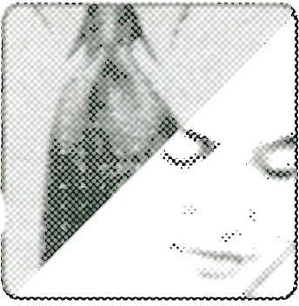

, "Love and Respect Golden Rule": the wife shoul res_pect her husband as she wants to be loved; the husband should love his wife as he wants to be

respected. Why is practicing this particular rule difficult? How can you help each other do it more consistently? (For some good review, see Chapter Two in *Love & Respect.)*

0n book page 71 Emerson states that he believes married couples are at a cross­ roads. Then he asks some penetrating questions. These questions appear below,

18

r-'estated to apply directly to you and your spouse:

GJ

Will you appreciate your husband's need for respect, or will you denounce his feelings? Will you discover that the best way to love a husband is by re­ specting him in ways that are meaningful to him? Or will you focus on what

you might feel is the key to a happy marriage-your womanly feelings-and dismiss his needs as antiquated chauvinism or male arrogance?

58 PA RT ONE-THE CR A ZY CYC LE

Will you appreciate your wife's need for love or just continue to ignore her feelings? Will you discover the best way to love your wife is to look beyond her criticisms and complaints to see why she isn't feeling loved? Or will you

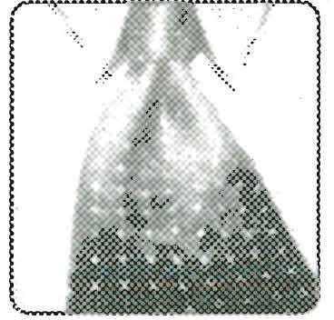

just cower before her apparent contempt and retreat to the shelter of your "stone wall?"

Spend some time in prayer as you answer these questions. It may be that you and your spouse are at the crossroads Emerson mentions. Will you take the fork labeled "Love and Respect?" Read the letter from the wife who, together with her husband, took that fork (book page 72). At this point in your study, are you gaining confidence that the simple message of *Love & Respect* really can work? Why or why not?

The many questions above can be heavy for both of you to deal with, but they can pay off handsomely in slowing and stopping the Crazy Cycle. Be honest, but sensitive to each other and share from the heart. '-----./

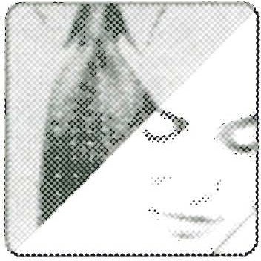

On book page 72, Emerson closes the chapter by admitting that at times he may sound like he is hammering wives for their lack of unconditional respect

19

for their husbands. He continues: "But I'm not trying to hammer wives-I'm trying to help them, because I know how pivotal the wife's respect can be in slowing down the Crazy Cycle. Yes, many men are unloving clods to one degree or another, but they can change. In fact, many of them want to change, and the best way to get them to change is treating them with unconditional respect."

SESS ION THREE *00* 59

Respond to the above paragraph from your point of view as a wife or a husband. Do you think Emerson is trying to help wives, not hammer them?

YES

**I think .** . .

No NOT COMPLETELY SURE, NEED TO KNOW MORE

Give this question some careful thought and discussion. Husband, if your wife is still feling a littl "hammere" even after readi.ng Eerson's assur­ ances that he is really trymg to help, listen to what she is saymg and do not

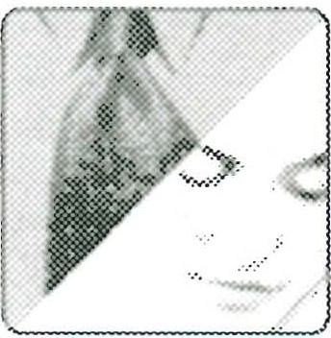

simply say things like, "You're foolish to worry,'' or, worse, "You may feel hammered , but it's what you needed to hear." Tell her that you want to be a more loving husband, and her respect can do nothing but help you achieve that goal.

As you complete this session, it may be a good time to review Question 18 and the answers you gave. Are you truly ready to take the fork in the road labeled

2O

,-----,Love and Respect"? Write down your honest feelings at this point:

You may feel the need to go over the heavy questions in Question 18 and talk about them a little more. G sloly with this. Be sensitive to each other and honor any doubts or questions either of you may have. You may want

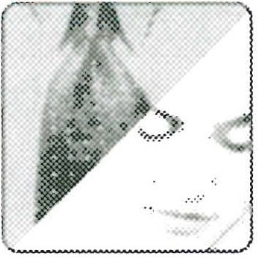

60 0':> PA RT ON E-THE CR A ZY CYC LE

to go back over Question 19 as well. Wives need understanding as they process what unconditional respect means to them and how they should act toward their husbands. Even though Emerson assures wives he is trying to help, not hammer, them, they may still feel a bit sensitive. Pray together about your study so far and your marriage. The Crazy Cycle is not easily slowed or stopped. It can be hard work, so let God help.

A JOU RNA L OF MY JOU RN EY TO LOV E AN D RE SPE CT

Continue creating your own journal by interacting with the following scriptures cited in *Love & Respect.* You may wish to make notes as you interact with Emerson's meditations. There is additional space to write your current thoughts about your

marriage and your study so far.

SCRIPTURE MEDITATIONS

1. In 1 Peter 3:1-2 Peter instructs wives to be submissive (give respect) to their hus­ bands, even if they do not believe or obey God's Word and are undeserving of respect. If a wife does this, Peter writes, her husband may be won over as he observes her "respectful behavior." What does Peter mean by "respectful behavior" on the part of a wife before her husband? I believe that part of what Peter had in mind includes a wife's tone of voice and facial expression. When he isn't the man she wants him to be (lov­ ing and considerate), can she still show him unconditional respect with the way shf'

talks and the look on her face? She is not asked to endorse his unloving actions; she is-./ asked to show him unconditional respect, j ust as he is supposed to show her uncondi­ tional love. Difficult? Very. But it can work wonders. As Peter implies, it is less about what a wife says (verbal language) and far more about how she comes across (non­ verbal language) . A good-willed husband, no matter how badly he might be fouling things up at the moment, will find it hard to continue resisting unconditional respect.

1. Why is it that Scripture instructs men to "fight for your . . . wives" (Nehemiah 4: 14), but women are never instructed to fight for their husbands? On the pages of any piece of well-known literature, does the prince see himself as the rescuer of the princess, or does the princess want the prince to depend on her for protection? If an

SESS ION TH REE *'*'* 61

intruder enters a home, what will the wife think if Harry screams, "Sally! Protect me! Go get that mean man out of here so I can stop huddling in the corner!"? What does a husband feel when his wife never respectfully acknowledges and praises his desire to protect her? Question for her: "Does my husband have a need to be respected (looked up to) in a way that I have been overlooking?"

1. In a marriage especially, "Reckless words pierce like a sword . . ." (Proverbs 12:18 NIV). How deep is the wound if a husband snarls in anger, "Nobody could ever love you!"? How deeply does it cut when a wife retorts: "Nobody could ever respect you!"?

,--"Jeither spouse "means it" but the effect is like a sword thrust, nonetheless. The Love and Respect couple works hard at never using "reckless" words, and instead heeds the rest of Proverbs 12:18: ". . . the tongue of the wise brings healing" (NN) .

1. A good passage for any married couple is Proverbs 14:8: "The wisdom of the pru­ dent is to give thought to their ways . . ." (NIV). As you reflect on your study of *Love*

*& Respect* so far, have you given much thought to your "ways"? As a husband, when

you feel disrespected, is your way of reacting loving or unloving? As a wife, when you feel unloved, is your way of reacting respectful or disrespectful? It is so very easy to rationalize that your way of reacting is solely the fault of your mate and to tell your­ self, "If my spouse changed, all would be well." Take the rest of Proverbs 14:8 as the Lord's warning: ". . . but the folly of fools is deception" (NIV). In other words, fools deceive themselves.

**My current thoughts about our marriage:**

**SE SSI ON Fou R**

This session is the last in Part One: The Crazy Cycle. Session Four covers Chapter< Five, Six, and Seven of the *Love & Respect* book and deals with some of the most fre,,.J quendy voiced issues raised by the thousands of couples Emerson has helped slow or stop the Crazy Cycle. In preparation for this session, read Chapters Five through Seven of *Love &Respect.* As you read, you may identify with many of the questions and con­ cerns others have voiced. You may prefer to concentrate on only one or two of the chapters, or you may find all three helpful. Choose what fits your situation. It is pos­

sible that none of these chapters will seem to fit your experience exactly. We suggest you go over them anyway, using the questions in Session Four as a review of key issues and principles that affect this marriage. Remember to answer all unmarked questions first, then answer questions marked by the male or female icon (whichever applies to you). Finally, answer the questions with the couple icon, if you're studying with your mate. (Suggestions for anyone planning to use this study with a small group can be found in *Workbook* Appendix I, page 201.)

#### Questi on s fo r Chapte r F ive

In the opening paragraph of Chapter Five (book page 73), Emerson relates that during many years of counseling couples, he has observed that old Crazy Cycle habits are hard to break. She may want to change, but "the rat needs to earn my respect" attitude dies hard. He would like to be different, but he fears looking like an

I

unloving fool-again. As you begin this session, where are you on this continuum?

SESS ION FouR *00* 63

1· ···-2:1 Do you have any fears of being a "doormat" if you really try to respect your husband unconditionally? Write your honest thoughts here:

Do you have any fears of looking like a fool if you try to unconditionally love your wife and fail-or she doesn't respond with respect? Write your honest thoughts here:

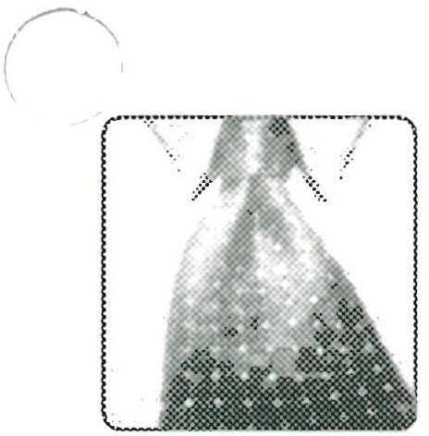

One (or both) of you may feel a little uncomfortable discussing your answer(s) to the questions .above. Admtting your fears an t_hen talking about them can be beneficial, but only 1f both of you are w1llmg to share

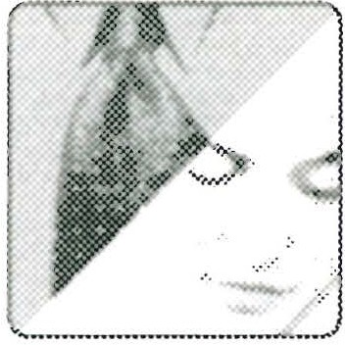

1vour hearts.

The concerns described in Question 1 raise another major question that spouses have. Read "Who Should Make the First Move?" (book pages 74-75) carefully.

2

What is Emerson's answer to spouses who wonder: "Should I make the first move?"

64 0<J PA RT ON E-TH E CR A ZY CYCL E

Why does Emerson claim that the spouse who makes the first move can rarely lose?

This is another question that you may feel reluctant to discuss. Even so, being willing o di_sc_uss this is, in a snse, being willing .to make the first ove! If one of you 1s w1llmg to take the nsk, the rewards will be well worth 1t.



In "Not a Doormat but a Woman with Power" (book pages 75-77), Emerson_,/ attempts to assure wives he is not a chauvinist in disguise, trying to lure them into

3

a life of subservience. Read this material carefully, then go down the "list of a wife's fears" below and check off anything that you believe is a concern in your marriage.

Which of the following fears concerns you to some degree at this time?

l =::.J If I respect him, he won't really be more loving.

'····----- ---··· If I respect him, I will wind up a doormat, and doing whatever he

wants.

If I respect him, I'll have to bury my brains, never think for myself or speak my mind.

If I respect him, he will ignore how I hurt and where I'm vulnerable.

If I respect him, he'll become arrogant and self-centered .

If I respect him, I'll have to do something I don't really feel, and that 's impossible.

My fear, in my own words, is:

Do you see anything in the above list that may be of concern to your wife? Check those concerns and be ready to talk about them.

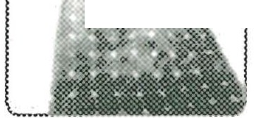

.

SEss 10N FouR *00* 65

This question provides plenty of opportunity for sensitive sharing. Wife, if you don't have any of these fears, you should tell your husband, which will be a big encouragement to him. Husband , if your wife does have fears about

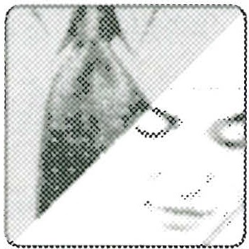

showing you unconditional respect, you can do several things: First, be thankful that she is courageous and humble enough to tell you. Second, remember she is a good­ willed woman who wants your love. Third, do not dismiss her fears as "silly" or just say, "Oh, you don't have to worry about that." Fourth, seek to understand her and empathize as much as possible.

*('*

According to "Not a Doormat but a Woman with Power" (book pages 75-77), one of the ways a wife feels empowered is when she corrects or "mothers" her husband (page 76). According to Emerson's counsel, why doesn't this work? Finish his observa­ tion on page 77: when a wife continues to mother, correct, or goad a husband into

4

changing, she wins the battle but loses .

This question is similar to Questions 13 and 14 in Session 3, which dealt "":ith the wife's scolin?. Ifyou choose to discuss this one, be .careful of sep­ pmg on each other s air hose. If the two of you can share without arguing,

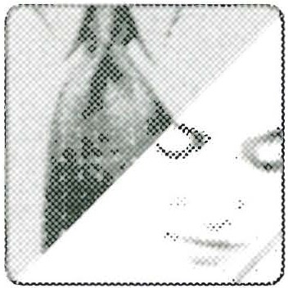

it will be helpful for him to explain when he feels he is being "corrected and moth­ ered," and for her to learn how she can come across a bit differently as she constantly

,,-s_ees things that need putting right. Remember, if you can avoid battling each other,

_nd see each other as an ally, not an enemy, you will win the war of the Crazy Cycle.

In "What IfYou're Afraid to Take the Risk?" (book pages 77-80), there are several letters from wives who were hesitant to try showing their husbands respect-but who trusted God anyway. Read these letters carefully. Write out phrases that may give

5

you help, hope, or assurance for your marriage.

66 PA RT ONE-TH E CRA ZY CYC LE

Husbands, while this question is designed primarily for wives, you can benefit from answering it as well and then comparing notes with your wife.

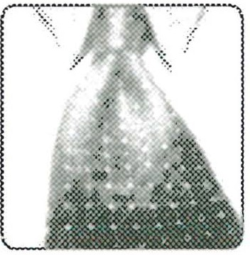

Can you identify with why the husbands described in these letters were so energized? As you share with your wife, what can you say to her to alleviate any fears or questions she may still have? Whatever you do, refrain from shaming your wife as she awakens to your need for respect.

In "Husbands, Remember Only One Idea-Love" (book pages 80-82), Emersor admits that there have been plenty of times when he has felt like the husband who-_/

6

wrote in to say: "I have spent the last twenty years literally consumed with trying to figure out what is going on in our marriage ." What has helped Emerson during those times? What are the two questions a husband must focus on when his wife gets criti­ cal or negative? (See book page 81.)

._,> JEven though Questio 6 i directed primarily toward. the husband, the wif _ ' . can benefit by answenng lt as well and then companng her answers to he\

l

__. _-_ husband's. As a wife, do you agree that when you get critical or angry you are actually saying, in one way or another, "I need your love, please love me!"? As a husband, are you remembering to ask yourself: "Will what I do or say next come across as loving or unloving?" Ask your wife how she thinks you are doing in that department .

SESS ION FouR *c:so* 67

?

Read the story of how "This Husband Decoded in Jail" (book pages 82-85). As he spent the entire weekend in jail, this man had an "epiphany experience" that helped him to finally understand his wife's angry messages . What stands out in this

story from your point of view as a spouse?

Compare your answers, which may be quite different. Concerning this man's story, Emerson says: "Husbands and wives please note: physical vio­ lence against a wife is reprehensible and evil. Sharing this man's letter



should not be construed as sanctioning such evil in any way. The story shows what can happen when God works in a husband's life and he learns how to decode his wife."

Two more letters from husbands who learned to decode their wives are on book pages

8

85-86. As you read these letters, make notes on some important ways a spouse can decode. What phrases or ideas stand out? Which ones should you use more often?

Copare your' answers. °"";,are all of these ideas about decoding summed up m Emersons observation, The Crazy Cycle can be slowed-and stopped

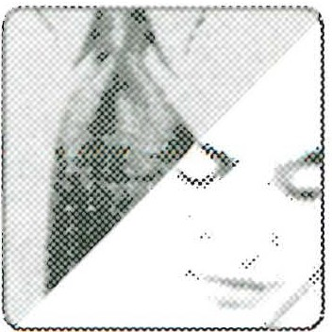

-if only we would have eyes to see and ears to hear"? Not only is it impor­ tant for you to "get it" (understand what you need to do), it is also very important to listen and respond when your mate "gets it" as well. (See Emerson's additional com­ ments on Question 8 in *Workbook* Appendix VI.)

68 01:> PA RT ON E-THE CRA ZY CYC L E

#### Qu esti on s for Chapter Si x

Chapter Six opens with a letter from a woman who was trying to respect her alco­ holic husband, but she did not "want to be a hypocrite." How does Emerson answer this concern (book pages 87-88)? Why does continuing with criticism and

9

anger only mean that a wife shoots herself in both feet?

This could be a delicate question, especially if the wife has any feelings about being a hypocrite as she tries to show the husad unconditional re­ spect. Go slowly and gently and remember that practlcmg Love and Respect

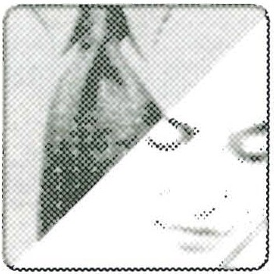

isn't about feelings; it's about doing what the Scriptures teach.

On book page 89 Emerson tells of having asked a wife: ''Are you afraid that your respectful manner will lessen your chances of motivating your husband to change?" Read her response, then write your own. According to Emerson, "Obeying

1O

God's Word does not make a wife a powerless hypocrite." Do you agree? Explain.

Husband, while this question is directed to your wife, write your answer as well, then discuss it with her. As your wife shows you respect, especially when you are not as loving as you could be, do you see her as "power-less"

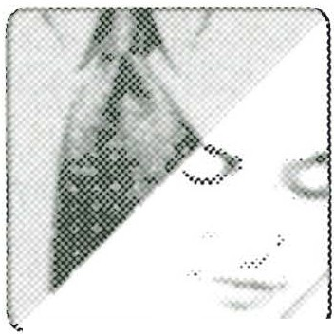

_

or "power-full"? Why?

SEss10N FouR *czso* 69

Read the letter from a wife at the bottom of book page 90, plus the paragraph at the top of page 91. What did she get out of being respectful? What has she

11

made sure to do in response to all his loving acts? How do you think the husband feels when he comes home to a clean house, a hot meal, and a wife who looks good and acts like she is happy to see him?

You and your mate may see this question as rather simple, not to mention ta it flies in the face of a culture where a stay-at-oe-spouse is unrealis­ tic m many households. Nonetheless, there are pnnc1ples here any couple

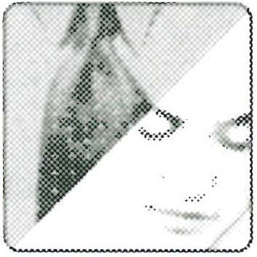

can apply. Today's woman expects her emotional needs to be met, even if she has a career, because her traditional need for love has not changed. Conversely, a husband has a traditional need for respect, but when he expresses it, some want to tar and feather him. If the way your spouse wants to be treated seems unrealistic or outdated, look beyond all the cultural baggage and see the deeper need to be loved or respected. Talk about why the Love and Respect Connection is so simple, yet sometimes so dif-

,,--- ::ult. Why can it be so powerful when used by two good-willed people?

70 *00* PA RT ONE-TH E CRA ZY CYC L E

12

Read "Refuse to Play Rodney Dangerfield- Don't Stonewall!" (book pages

91-92). Instead of muttering, "I just don't get no respect," husbands are to move toward their wives even when they are receiving "verbal deathblows." How does Proverbs 12:16 help a husband when his wife is being abusively disrespectful?

Handle this question (and each other) with care. As a husband, you have the opportunity to apologize for the times you "stonewalled" your wife when you received what felt like "verbal deathblows" from her when she felt

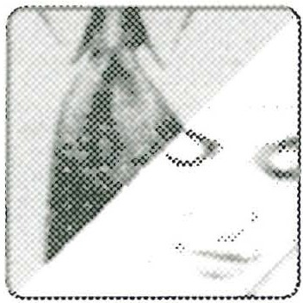

angry (and unloved). Tell her that from now on you want to follow Proverbs 12:16 and "conceal the dishonor." In other words, no stonewalling-no getting angry in return. You just want to keep coming with unconditional love. As a wife, you have the opportunity to apologize for your anger and promise to give your husband uncondi­ tional respect. Both of you realize you can't be perfect at practicing Love and Respect, but you also know that just being willing to try means real progress . Pray together for guidance as you seek to slow and stop the Crazy Cycle.

In "I Used to Say, 'I'll Show Her!"' (book pages 92-94), Emerson confesses how he reacted badly to Sarah when feeling disrespected. Then he discovered a

13

way to motivate her to be more respectful, which in turn motivated him to be more loving! Read this section carefully and find the combination of short sentences Emerson used to develop what amounts to the "Love and Respect 'I' Message." Also turn to *Love & Respect* Appendix A, page 306, "To communicate feelings or start dis­ cussion," where an example is given for the wife as well as the husband. To start mem­ orizing the "Love and Respect 'I' Message," fill in the blanks below:

As a husband, you can say: "That felt . Did I just come

**across** as ?"

SESSION FOUR 71

As a wife, you can say: "That felt . Did I just come across as

?"

###### ----------------

Note on book page 306 what you are to say if your spouse answers yes to your ques­ tion. Is the "Love and Respect 'I' Message" something you can use in your marriage? Write your thoughts:

Compare your answers and also discuss what Emerson and Sarah have done when angry, which is stated in Ephesians 4:26 (see "It Works-Even on Our Bad Days," book page 94). Read this verse together. Could this verse



change the way you deal with anger?

In "IfI Can Do It, So Can You" (book pages 95-97), there are two letters from struggling husbands (bottom of page 95, top of page 96). Finish this bit of ad­

14

vice Emerson gives both of them: "Gentlemen, it is true you are not designed by God

*r )* enjoy contempt, but He does call you to ."

As you talk together, note the comments by marriage researcher John Gtman who concluded it is more effective for a husbnd t ebrace his wife s anger (bottom of book page 96). (For more discuss10n ideas, see

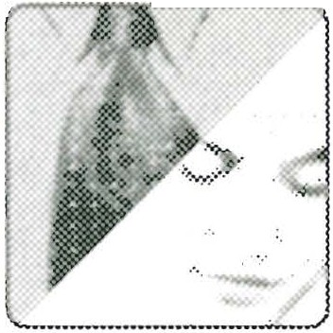

Emerson's additional comments in *Workbook* Appendix VI.)

At the bottom of book page 96, top of 97, Emerson suggests what a husband can say if his wife vents her feelings with venomous remarks: "Honey, I love you. I

15

don't want this. When you talk this way, I know you're feeling unloved. Let's work on

72 0':> PA RT ONE-THE CR A ZY CYCLE

this. I want to come across more lovingly, and I hope you would like to come across more respectfully."

Because a husband does not love naturally, God commands him to do so (see Ephesians 5:25-33). It may never feel "natural" to say something like what is quoted above, when your wife is venting her anger at you, but as a

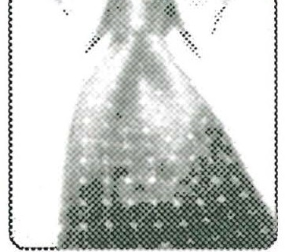

man of honor, are you willing to try it?

YES No NOT SURE

lJ

If your hsband use Emeron's suggestions when yo_u were venting your

- anger at him, how might this make you feel? Would it help? Why or whyj

. _ not?

Compare your answers. Is Emerson's suggestion for turning aside a wife's anger something that could work in your marriage right now? Talk about how it would feel in the middle of an argument or angry exchange for the

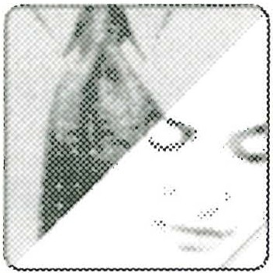

husband to talk about wanting to be more loving and hoping the wife could be *mo1* respectful. (For more ideas on defusing anger, see "Things to Remember," *Love &'/ Respect* Appendix A, pages 305-6.)

Read the story of "The Husband Who Never Stopped Loving" (book pages 97-99). Note two or three things that stand out for you in the wife's letter

16

about how her husband wouldn't give up on her, even when it seemed hopeless.

SEss10N FouR *00* 73

Compare notes, then talk and pray about your own marriage. Emerson adds this note on the value of prayer: ''As you go through this study of *Love*



_

*& Respect,* you may have moments of feeling overwhelmed. All husbands

and wives who are believers in Christ have His promise: 'Come to Me, all who are weary and heavy-laden, and I will give you rest' (Matthew 11:28). And Peter adds: '[cast] all your anxiery on Him, because He cares for you' (1 Peter 5:7). Ifyou are feel­ ing weary and heavy-laden, will you pray to the Father? Will you cast your anxieties on Him? Do this because He cares for you. Jesus, the Perfect One, depended on the Father while on earth. All God's children are free to do the same. Depend on God for

**,.---.,ll** your needs . He is eager to help you!"

Read carefully the second paragraph on book page 99 (beginning, "No matter how desperate or hopeless a marriage may seem . . ."). What do you think? Can

17

love and respect, plus basic goodwill in both spouses, conquer anything?

ITOTALLY AGREE IPARTIALLY AGREE IDOUBT IT

**My comments:**

You may know people who face tremendous problems in their marriage such as adultery, abuse, or addictions. You may face remendous problems yourself. Does Love and Respect work when the going gets really tough?

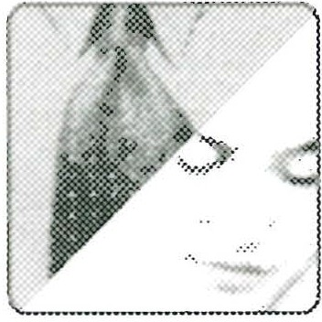

(Those who may need specific help to deal with adultery, spousal abuse, and drug addictions, go to the following Web site: <http://www.loveandrespect.com/pearl.)>

74 PA RT ON E-THE CRA ZY CYC L E

### Qu esti ons for Chapte r Seven

As he has counseled wives over the years, Emerson often hears comments like these: "Forgive him? Yes, I know what Jesus said about seventy times seven, and

18

I've forgiven him at least that many times! But when is he going to ask me for forgiveness? When is he ever going to care about how much he hurts me?" Is there some truth in com­ ments like these? Shouldn't a husband ask for forgiveness in order to be forgiven? Can granting forgiveness, even when it isn't wanted, really help the situation at all? Read the opening book pages of Chapter Seven (101-3). Then put down your response to Emer­ son's teaching:

Talk about what it means to forgive. Do you agree with Emerson's assertion that when you forgive someone for being unloving, you give up your right to hold a grudge? Note the letter from the wife on page 103. What insights

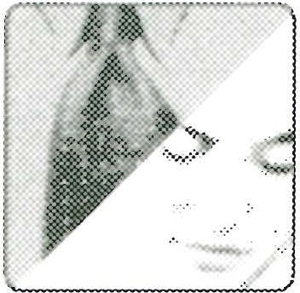

does she provide that might make forgiveness possible, even if it doesn't seem prac­ tical? Husbands, don't skip this material because it seems to be directed to wives. You may need to do some forgiving yourself, or perhaps it is time you asked for forgive­ ness. Forgiving someone, or being forgiven, can be a humbling experience. Each *OJ.j* you should try to be sensitive to the other's needs at this time.

At the bottom of book page 105, Emerson writes, "Nothing is easier than judg­ ing, nothing is harder than forgiving, and nothing can reap more blessings."

19

Read the letters from the wife whose husband strayed into adultery (pages 104-5).

How did she find it in her heart to forgive him? What was her driving motivation?

SESS ION FOUR c:9:> 75

Compare notes on what you see in this woman's letters. She faced having to decide to forgive her usband at the harest level: .for hi immorality:It ay

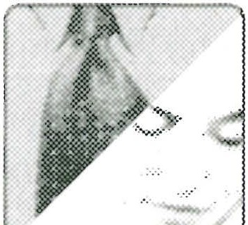

-- be of help to spend time together readmg and discussmg Emersons views

Jn forgiveness at two levels (see *Workbook* Appendix III, page 207). He gives sound biblical advice to the spouse who has been wounded deep in the heart by a mate's adul­ tery. For the woman who wrote the letters, her strongest motivation was, obviously, her faith and trust in God. She had no trust for her husband, and little or no inclina­ tion to forgive. But when she did, he responded . Emerson adds: "Situations like this do not always have such a happy ending, but God calls us to obey Him and His word, one step at a time, and to accept what happens as His will."

Read book page 106, "IfYou Fail to Love Her, Rebound," then respond to the following:

2O

How good a rebounder are you? (In other words, how well do you bounce back when you are unloving and get clobbered with contempt?)

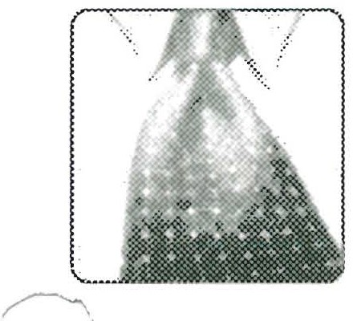

J·········· How good a rebounder is your husband when you criticize him with good



_ reason? (For that matter, how good a rebounder are you when he reacts to your disrespect?)

76 *C:50* PA RT ONE-TH E CRA ZY CYC LE

Talk together about Emerson's "rebound" analogy. Even if you know noth­ in? about basketall, the priciple is there to use: a good rebounder is deter­ mmed to try agam and agam. Do one or both of you need to be a better



rebounder?

Read Emerson's humorous account of how he has had to rebound after blow­ ing it with Sarah (bottom of book page 106 to top of 109). What truths in his

21

transparent admissions stand out for you?

As a husband, note especially the two choices you have if your wife comes at you "with disrespect flashing in her eyes and venom shooting from her tongue": defend your pride or surrender with unconditional love. As a wifr

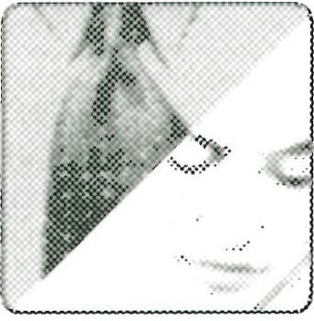

how would you respond if your husband said, 'Tm sorry. I know I've been unloving'·:- ,.;

SEss 10N FouR 77

22

In "Marriage-A Two-Become-One Proposition" (book pages 109-12),

Emerson claims that when couples practice love and respect, "Bad mar­ riages become good, boring marriages become exciting, and good marriages be­ come better." Note these words from a husband who from all appearances had a good marriage (and even conducted marriage seminars with his wife): "On a scale of 1-10 we were living with a 5-6 marriage most of the time." When he and his wife started making Love and Respect a priority, that number went way up. How would you rate your marriage right now on a scale of 1-10, with 10 being "great"?

_ pur marriage is a .

Be aware that this question could be difficult to discuss. Be sensitive to each other and willing to hear the other person's reasons for the number he/she chose. Concentrate on agreeing about how you can work together to make

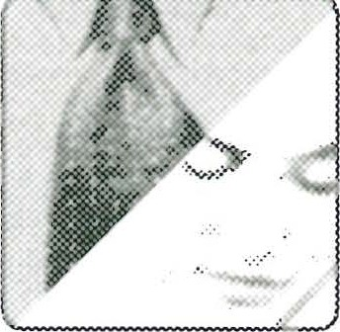

that number higher.

In "From the Crazy Cycle to the Energizing Cycle" (book pages 112-13),

23

Emerson reminds spouses that you can slow or stop the Crazy Cycle, but you can never get off completely. He and Sarah know they have to work continually at controlling the Crazy Cycle, and some of the best ways they have learned to do this are stated in capsule form in *Love & Respect* Appendix A, especially in ''Always Ask Yourself " and "Things to Remember" (pages 305-6). Take time to go over these sug­ gestions now, and write down several ideas that stand out as things you want to prac­ tice as you move into Part II-The Energizing Cycle.

*1·*

As you complete your study of Part I: The Crazy Cycle, share and pray to­ gether concerning these questions:

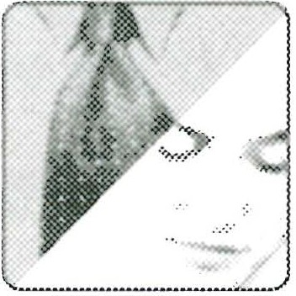

--

1. How much progress have we made in slowing and stopping the Crazy Cycle?

78 c:50 PA RT ONE-TH E CRA ZY CYC LE

1. What can we do, as a couple, to keep the Crazy Cycle under control?

A JOU RNA L OF MY JOU RN EY TO LOV E AN D RES PECT

This section of your workbook is your private area to write whatever you are thinking or feeling at this time. The Scripture Meditations can help you start thinking and praying and putting down what is on your heart. There is also room to record any other current thoughts about your marriage.

SCRIPTURE MEDITATIONS

1. In your marriage, be the first to "seek peace and pursue it" (1 Peter 3:11). Can you say you are the one in your marriage who consistently seeks peace and pursues it? Do you ever seek peace at any price, ignoring or compromising the clear teaching of Scripture? Or, do you stubbornly and selfishly demand your own way in small matterc because you foolishly make these "little things" symbols of how you are unloved or dis_..) respected? Consider this wife's letter: "I turned the temperature down last year . . . [then] my husband bought a plastic box that fits over the dial complete with lock and key. . . . I was appalled when he put a locked box over the temperature dial. . . . I found

a way to change the dial without using the key [and] I turned the heat down to 68. This has always been an area where we don't agree. He told me last month that he felt I was being disrespectful." How would you answer this wife? At this rate, why will she and her husband not experience peace? How could they change in an attempt to seek peace?

2. It is always wise for a husband to be "humble in spirit" (1 Peter 3:8). What does it mean for a husband to be humble in spirit? Will a wife walk all over a husband who approaches her in this way?

SEss10 N FouR 79

1. Over the years, as I have blown it and been unloving to Sarah, I have found solace in Proverbs 24: 16: "Though a righteous man falls seven times, he rises again"(NIV). The husband who tries to live an honorable life with his wife, but fails, knows two things: (1) He is "righteous" only through the blood of Christ; (2) he can no more always show his wife perfect love than she can show him perfect respect. What does Proverbs 24: 16 tell the husband or wife to do in the moment of failure? The last time you came across as unloving or disrespectful what did you do?
2. To stop the Crazy Cycle, and keep it in its cage, seek to obey God's Word "which

•lso performs its work in you who believe" (1 Thessalonians 2:13). We have God's promise that His Word will do His work deep in our souls! Your marriage isn't first about performance; it's about God doing a work in and through you: ". . . for it is God who is at work in you, both to will and to work for His good pleasure" (Philippians 2:13) . As you live with your spouse, stop at least once each day and pray, "Dear God, perform Your work in me. Do Your work through me. Please, Lord, I need You!"

**My current thoughts about our marriage:**

**TH E**

**PA RT Two:**

# EN E RGI Z I N G CYC LE

Sessions 5 to 12 cover Chapters **Eight** to Twenty-Two of *Love & Respect*

A PERSONAL WORD FROM EMERSON:

I hope you have made progress to this point in slowing or stopping the effects of the Crazy Cycle on your marriage . Your next step is to learn how to keep the Crazy Cycle from spinning, or how to stop it if it seems to be starting up again. You can do this by getting on the Energizing Cycle in which his love motivates her respect and her respect motivates his love.

To help you get on the Energizing Cycle and stay there, I developed two acronyms covering six important principles for each spouse. The acronym C-0-U-P-L-E con­ tains advice for husbands in six brief chapters on Closeness, Openness, Under­ standing, Peacemaking, Loyalty, and Esteem. The acronym C-H-A-I-R-S contains advice for wives in six brief chapters on Conquest, Hierarchy, Authority, Insight, Rela­ tionship, and Sexuality.

'--'

Keep in mind that if you are studying together with your spouse, discussing some of

these questions may be tough going. Husbands and wives need to be sensitive to each other and take it slowly, easily, and gently. There is no rule that says you must exhaus­ tively discuss every question . Some questions may prove sticky, even irritating to one or both of you. The first rule in being a Love and Respect couple is to do just that­ show love and respect to each other! This will mean not always saying everything that may be on your mind. Be honest, but not brutally honest. (Speak the truth in love­ Ephesians 4: 15.) Remember, having a difference of opinion or a different understand­ ing of something does not mean you have major problems as a couple. What you must

PA RT rlwo *00* 81

guard against, however, is allowing disagreements to turn into disapproval of the other person . Always, the goal is Love and Respect, whether you agree or disagree. The hus­ band should focus on loving his wife, the wife on respecting her husband . If you do this, the Energizing Cycle will hum along nicely and the Crazy Cycle will not have a chance to spin.

**SESSION FIV E**

In preparation for this session, read the first two chapters in Part Two of *Love & Respect,* which covers the Energizing Cycle. Begin with Chapter Eight, "C-0-U-P-L-E,_j How to Spell Love to Your Wife," and Chapter Nine, "Closeness-She Wants You to Be Close." The following questions are for individual study or study by a couple.

Remember to answer all unmarked questions first, then answer questions marked by the male or female icon (whichever applies to you). Finally, answer the questions with the couple icon, if you're studying with your mate. (Suggestions for leading a small group can be found in *Workbook* Appendix I, page 201.)

This session opens your study of C-0-U-P-L-E, six important principles that will help a husband learn important aspects of loving his wife. In Love and Respect, just under the title of Chapter 8, is a brief note to wives saying the next several chapters are for "husbands only, but wives are invited to read along." Wives are also invited to study along in Sessions 5-8 of this workbook, so please do! As your husband discusses the six parts of C-0-U-P-L-E with you, he will learn more about how to love you (and you will learn how to help him do it better!).

A SPECIAL WORD FOR HUSBANDS FROM EMERSON:

Welcome to the Energizing Cycle and your study of the acronym C-0-U-P-L-E: Closeness, Openness, Understanding, Peacemaking, Loyalty, Esteem. These are the six principles you can practice to make your wife feel loved. More than that, you can use C-0-U-P-L-E as a diagnostic tool to tell when you and your wife are slipping off the Energizing Cycle and back on the Crazy Cycle. According to the Crazy Cycle, a wife acts disrespectfully when she isn't feeling loved. Her disrespect is not justified, but when it does happen you can say to yourself, "Since my wife is reacting in ways that

SESSION FIVE *00* 83

feel disrespectful to me, there is a good chance I have done something to make her feel unloved. I have two choices: react to her unlovingly, or try to decode. Which one of the principles in C-0-U-P-L-E might I be neglecting in her view?" This way you soften your reaction, as you remember that your wife is basically a good-willed woman who is not intending to show you contempt.

Next, depending on the situation (what has been going on between the two of you), you can probably make a good guess at what's wrong. For example, you've been work­ ing long hours, and she is feeling the need for closeness. Talk to her and ask if this

,.,-is what is wrong. If she says it is, you can say you are sorry for your behavior, make

_,_djustments, and get the Energizing Cycle going again.

But what do you do if, for whatever reason, you can't decode (figure out what is bothering her)? If that happens, you can communicate your feelings to your wife by gently (not defensively or aggressively) saying, 'Tm feeling disrespected right now. Have I been coming across as unloving? How can I come across more lovingly?" (In other words, tell me where I am messing things up.)

I believe that as you go through C-0-U-P-L-E for husbands and C-H-A-I-R-S for wives, you will get to know each other better than you ever have before as you are chal­ lenged, stretched, and, I hope, blessed. But remember, if any of the questions in the following sessions makes either of you uncomfortable, agree together to table that item for right now. Later, you may be ready to come back and discuss the topic with real profit as you go to new levels of Love and Respect. But for now, let's get going with the Energizing Cycle-and have a great trip!

##### Questi ons for Chapter Eight

To get started with Session Five, the six words represented by C-0-U-P-L-E are listed below. Next to each word is a brief definition. Under each word, write what

1

it suggests to you. Does your definition match the one given?

*Closeness: She wants you to be close.*

My **definition:**

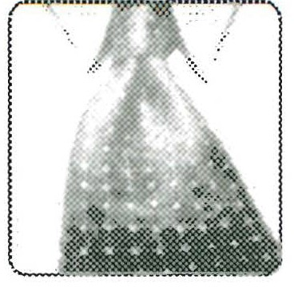

84 '*' PA RT Two -THE ENE RG IZ ING CYCLE

*Openness: She wants you to open up to her.*

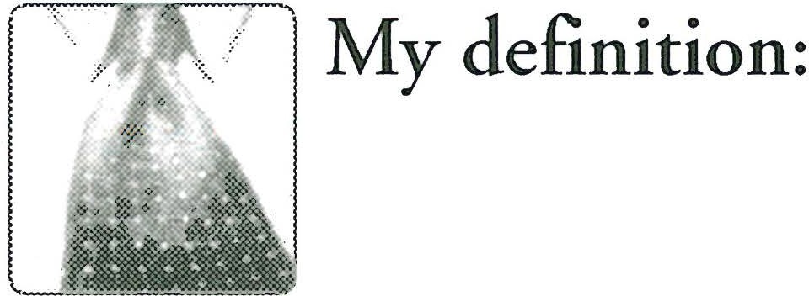

*Understanding: Don't try to 'Jix" her; just listen.*

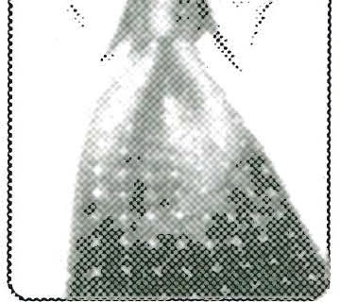 My **definition:**

*Peacemaking: She wants you to sa.)4 'Tm sorry.* "

T' My **definition:**

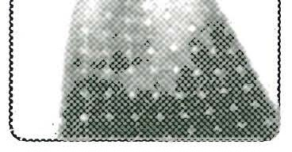

*Loyalty : She needs to know you're committed*

, *' ,')\:* My **definition:**

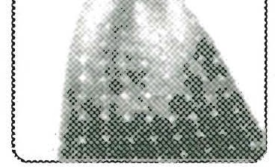

SESS ION Fr v E 85

*Esteem: She wants you to honor and cherish her.*

My **definition:**

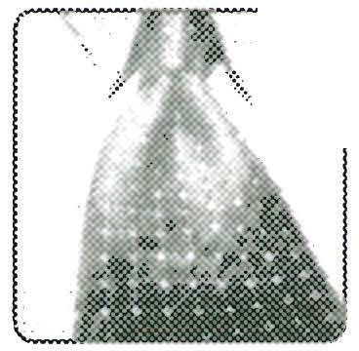

'

'Vhich of these six principles sounds most interesting? Which is most necessary to a happy marriage? Why?

Husbands and wives should compare their respective definitions and dis­ cuss them. How did they differ from the definitions given? How does your definition differ from your spouse's? How do your answers to the other two

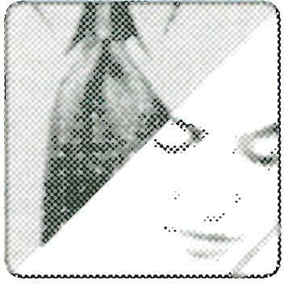

questions differ? When your study of C-0-U-P-L-E is complete, see if your opinions have changed and note why they might have changed.

')On book page 118, Emerson defines the acrostic word C-0-U-P-L-E as "two peo­

*r* **'.•.t ple** connected together." What does it mean to you to be "connected" to your spouse?

86 PA RT Two-TH E ENE RG 1z 1 NG CYcLE

This question could prove sensitive, especially if the husband sees his wife's efforts to connect with him as an effort to control him. Go over book page 118 again. Wife, do you agree that when you come across as negative and

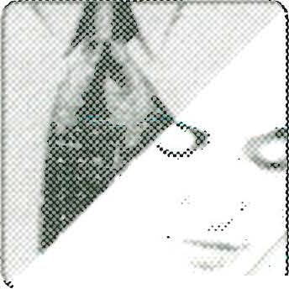

. .

offensive you are really crying out for C-0-U-P-L-E, the things your husband can do to connect with you? Husband, can you see yourself starting to decode your wife's messages, which may sound negative, but are really her cries for your love?

Farther down on page 118 Emerson writes, "Wives want connectivity. . . . Womer confront to connect." Why is this good? How can it turn out "not so good"? ,_,,

3

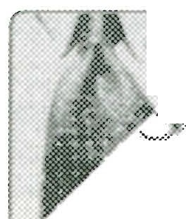 *Discuss* youc answecs and learn a little mote about one anothec.

4

In "This Husband Wouldn't Believe Me Until . . ." (book pages 118-20) is a story about a husband who saw his wife's effort to connect by confronting as an effort

to control him. He finally "got it" and realized this was not true, but only after attend­ ing a Love and Respect Conference. Why do many men fear being controlled? HO\ .., could understanding this fear help prevent the Crazy Cycle from spinning? Who needs

to understand it more-the husband or the wife?

SESSIO N F1vE *c:so* 87

Generally speaking, men want to be responsibly in control. See especially Session Ten, under C-H-A-I-R-S, which talks about the wife respecting the husband's desire to protect, provide, serve, and lead. All of these involve be-

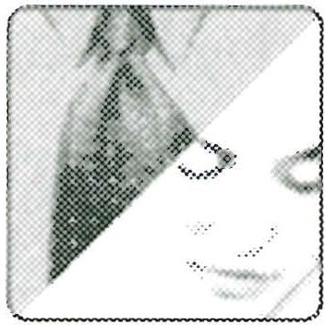

ing responsibly in control to one degree or another. When a husband feels his role in any of these areas is threatened , he may start to think his wife is trying to control him. ("She's trying to mother me.") On the other hand, if a wife feels her husband is being too dictatorial or demanding, she will feel unloved. ("He treats me like a doormat!") Talk together about the issue of control. Wife, let your husband know you are not try- ng to "wear the pants"; you only wish to connect with him. Husband, ask your wife

.or honest feedback about how "controlling" you are in your marriage. A good-willed husband wants to be a loving and responsible servant-leader. Talk about how the hus­ band's control can be good as long as a wife feels secure, but bad if she starts to feel unloved. Perhaps the key phrase is "responsible servant-leader." What does that look and feel like to each of you?

Read carefully the "Learn to Trust Your Instruments" section on pages 120-21.

5

How can practicing C-0-U-P-L-E prevent "marital vertigo?" Husbands, are you willing to "trust your instrument panel"?

No PROBLEM NOT TOTALLY SURE DOUBTFUL

Husband, discuss your answer with your wife and share any doubts you may have about how well you can practice the principles in C-0-U-P-L-E (that is, "trust your instrument panel"). For example, are you willing to ask

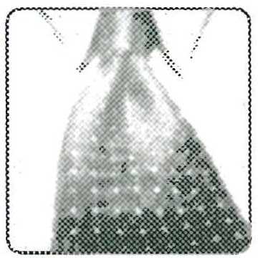

her if she confronts you to connect or control? (In other words, does she want to con-

88 "*' PA RT Two-THE ENERG IZ ING CYC LE

nect to create mutual understanding or is she confronting to control you and get her way?) Many wives are also mothers (or want to be), and it is in their nature to be help­ ful. Not only that, but wives are called to be "helpers" (Genesis 2:18). Can a wife seek to help her husband and come across as controlling without meaning to? Should the husband be willing to trust her goodwill, even though her helping can make him feel like she is being "bossy" at times?

In "In the Ocean of Conflict, Men Sink Unless . . ." (book pages 121-22), Emer­ son shares the story of one husband who had the guts not to stonewall his angry

6

wife. How would you describe what he did as he "trusted his instrument panel"?

Compare your answers, which could be very revealing by showing how each of you think. Also see *Love & Respect* Appendix C (page 311), which lists "need communicator" statements both of you can use when appropriate.

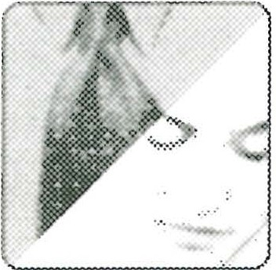

At the bottom of book page 122, as he summarizes Chapter Eight, Emerson writes, "To turn to your wife in the middle of a conflict and say, 'I am sorry, will

7

you forgive me?' takes guts. I know because I have been there. It isn't pleasant, but it works powerfully. Over time it becomes easier, but it is never natural. Even so, this re­ sponse gives you the power to drain negativity out of your wife in conflict after con­ flict." Why does it take guts to say 'Tm sorry"? What often stands in a husband's way?

SESS ION F1vE *00* 89

This can be a good question to discuss, but only if both of you are "up for

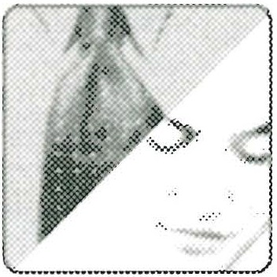

it." e, sensitive to. each othe, 's, needs ad, f fesible, tlk_ together about why lt *s* hard for him to say, I m sorry. Is it pnde? Or is lt fear that later

*r-* -;he will use his apology against him in a disrespectful way?

**Quest i on s for Chapte r N i n e**

Chapter Nine opens with a biblical definition of *closeness* (book page 125). Write that definition below and be sure to add what it means "to cleave." Obviously

8

"cleaving" involves sex, but what other kinds of closeness are involved?

Talk together about what closeness means to each of you. How important is it for the husband to let his wife know he wants to be close with a look, a touch, or a smile?

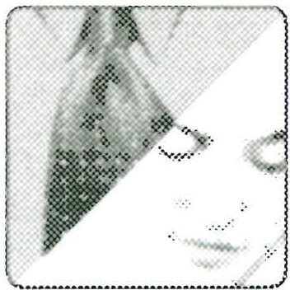

90 0<? PA RT Two-THE ENERG IZING CYC LE

Read carefully "The First Few Seconds Set the Tone" (book pages 126-27). Why are those moments when a couple comes together after being apart all day so im­

9

portant to the wife?

Share your answers, then talk about how you are doing during the first few moments when you arrive home. How easy is it to be perfunctory, pre­ occupied, and self-absorbed with your own needs? Is Emerson saying cou­

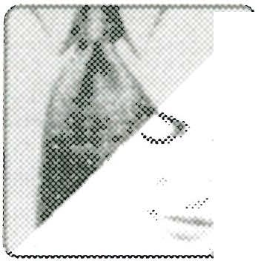

1

ples have to spend a lot of time reconnecting? What is more important-quantity or quality? Take a good look at what the two of you have been doing to reconnect after a busy day. What is your typical routine? Is Emerson right when he says, "The first few moments of reconnecting will set the tone for the rest of the evening"? If you agree with him, you may want to talk about changing your usual routine and spending at least a few minutes talking about what each of you did that day-achievements, frus­ trations, humorous incidents . . .

How important is face-to-face connection? (Read "What My Four-Year-Old Taught Me . . ." book pages 127-28.) Question for husbands: How are you

1O

doing at face-to-face with your wife? Question for wives: How can you respectfully

SESSION FIV E *00* 91

ask your husband for more face-to-face connecting? (See *Love & Respect* Appendix C, under "Wives can humbly and softly say," page 311.)

/'-

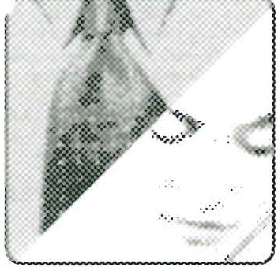

Not every husband will appreciate being confronted about his face-to-face time with his wife, particularly if he hasn't been doing it that much. Wives should be sensitive to this. In addition, Emerson adds an important point:

"If a wife wants to encourage her husband to be close face-to-face, she must always

consider what her face looks like. I'm not talking about looking like some cover girl; I mean the facial expression, which can be sweet and welcoming or sour and rejecting. From his extensive research with thousands of married couples, John Cottman con­ cluded that 'Wives who make sour facial expressions when their husbands talk are likely to be separated within four years.'i When a husband does move toward a wife face-to-face, she should think about showing respectful interest. At the same time the husband should place importance on looking like he wants to be close and loving, not like he is in a board meeting. For both spouses the emphasis is always on being hum­ ble and gentle as you seek to meet each other's needs."

Read the sections entitled, "Involvement or Independence?" and "Only Chick­ ens Get Henpecked" (book pages 128-30). Then mark the line below accord­

11

ing to what you need-more involvement with your spouse or more independence from your spouse.

**Involvement** ------------------- **Independence**

According to Emerson, "In the typical marriage relationship, she leans more toward the 'Involvement' side while he leans more toward the 'Independence' side." Talk together about the amount of tension you see in your marriage,

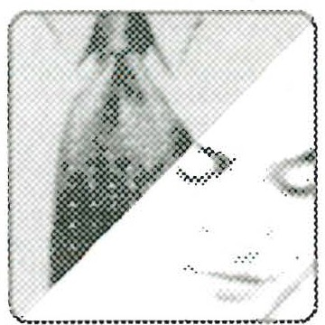

i John Gortman , *Why Marriages Succeed or Fail* (New York: Simon & Schuster, 1994), back cover.

92 *00* PA RT Two -TH E ENERGIZING CYCLE

between her need for involvement and his need for independence . Remember, this kind of tension is normal, so think positively about how you can solve his need for 'space' and her need to be 'close.' If this subject isn't too sensitive, discuss what Emerson says on book page 129 about a wife not wanting her husband to become like a "girl friend," but how even small moves toward closeness by the husband can ener­ gize the wife. Wife, do you agree? Husband, are you willing to give up a little inde­ pendence in order to be a little closer to your wife? What might happen if you did? For more tips and helps for talking together about something like this, see *Love & Respect* Appendix A, page 305-307, especially "Always ask yourself," "Things to remem-

ber," and "Things to say to lighten up the relationship." '-_,;

According to Emerson, there is a battle to the death going on between the Crazy Cycle and the Energizing Cycle (pages 130-31). What suggestions does

12

he make in this section to help husbands win that battle and have a great marriage? Check off phrases that sound helpful to you, or write down your own ideas.

Always seek to motivate and not demoralize.

_ Always be trying to adjust your "sunglasses" and "hearing aids."

Always try to do the positive, loving thing.

I think:

S ESS ION FIVE *00* 93

While this question is directed primarily at helping husbands love their wives, the suggestions listed above can easily be used by wives who want to respect their husbands. Do you both agree with Emerson's assertion that



"this is a war-a battle to the death between the Crazy Cycle and the Energizing Cycle"? Why or why not?

*( '*

Chapter Nine closes with tips and techniques for being close (book pages

13

131-33). Go down the list and find things that you are doing well. Then find one thing that you have not done for a while. Write it here, then plan how you can do it in the next twenty-four hours .

Husband, take time to ask your wife what she would like. (Maybe she will just want you to surprise her.)

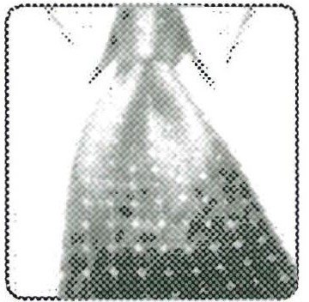

'

A JO U RNAL OF MY JOU RN EY TO LOV E AN D RES PECT

Always take at least a few minutes to write down your feelings, questions, insights gained, and other comments when you finish a study session. Months, or even years,

94 *00* PA RT Two-THE EN ERG IZING CYC LE

from now, you will appreciate reviewing this record of your growth as a person and a spouse.

SCRIPTURE MEDITATIONS

1. "When I found him whom my soul loves; I held on to him and would not let him go" (Song of Solomon 3:4). A woman in love longs for closeness. Husband, does your wife's need for face-to-face closeness seem like "clinging" to you? At the same time, is it okay for her to request face-to-face talking and physical closeness without wanting sexual intimacy? Serious tension can develop if a husband constantly reads his wife'r

desire for closeness as an invitation to have sex. What can a couple do if this is the case:" One solution that I have seen work in many marriages is getting on a schedule to take the guesswork out of when you will be sexually intimate. This kind of schedule leads

in turn to regular, scheduled times for face-to-face interaction without the husband pushing the sexual issue, because he knows the schedule. Does this sound rigid and non-spontaneous? Nonetheless, it can work miracles in a marriage.

1. A wife always hopes, "Now my husband will hold me close" (Genesis 29:34 CEV). Husband, have you ever heard your wife say, "I need a hug"? God seems to have made women for closeness and hugs. When women friends greet each other, do they hug or shake hands? For a group photo, do several women stand shoulder to shoulder as men would do, or do they squeeze close together, almost cheek to cheek for the camera? When your wife wants you to hold her close in a nonsexual way, does she have some problem with you, or is she simply a woman expressing her womanly desires? Is she wrong for having these desires, or just different from you? Ifyou have not been that aware of this female need for hugs and closeness that don't always lead to sex, what li de change will you make that can make a huge difference in your wife's feeling loved?
2. As Paul seeks to advise the Corinthians concerning a dispute that had arisen in their church, he says, "In the Lord, however, woman is not independent of man, nor is man independent of woman" (1 Corinthians 11:11 NIV). In other words, the basic New Testament principle is that women and men are equal before God. Eugene Peterson puts it well when he paraphrases this verse in *The Message.* "Neither man nor woman can go it alone or claim priority." there is great truth here for today's Love and Respect couple: there is always the temptation to become too independent of one another, particularly on the man's part. Because a man leaves father and mother (Genesis 2:24),

S ESS ION FIV E *00* 95

his tendency is toward independence. The rypical man, who does not have the same emotional need to connect as his wife does, should continually ask himself some im­ portant questions: Am I choosing activities that keep me too far away from her? Am I engaging in activities that keep me too independent and justifying them as "my right" or "something I need"? Do I sometimes change my plans but do not bother to inform her? Do I take on still more responsibilities (for example, in the church, on the job, in the communiry) even though my wife is overwhelmed at home with our children? Do I withhold information from her that she should know? Do I make decisions without including her, even though these decisions impact her significantly? Go over these 1uestions, and anything else where your wife may be complaining about your being

too independent (not involved enough at home). If the answer to any of these ques­

tions is yes, perhaps it is time to talk and pray with her about changes you could make.

**My current thoughts about our marriage:**

**SESSI ON Six**

Inpreparation for this session, read Chapter Ten, "Openness-She Wants You to Oper Up to Her," and Chapter Eleven, "Understanding-Don't Try to 'Fix' Her; Just Listen .'-- / The following questions are for study by an individual or by a husband and wife to­ gether. Remember to answer all unmarked questions first, then answer questions marked by the male or female icon (whichever applies to you). Finally, answer the questions with the couple icon, if you're studying with your mate. (Suggestions for anyone planning to use this study with a small group can be found in *Workbook* Appendix I, page 201.)

**Questi ons for Chapte r Ten**

As he begins Chapter Ten (book page 135) Emerson shares from his counseling experience, describing how couples act when they come in to see him. Men tend

I

to be closed, playing it close to the vest. The wife is much more open, wanting to talk and connect with her husband. Does this describe you and your spouse-the husband more quiet and closed, the wife more open and talkative?

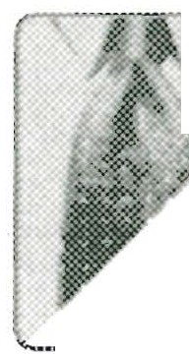

FITS US PERFECTLY SOMEWHAT TRUE OF US NOT TRUE OF US AT ALL *-J*

" · ..j

Compare your answers. Ifyou both believe this is true of the two of you, at

°' least to some degree, talk about it as much as feels comfortable. The typi­

-------=- cally "closed" husband may not want to go into it to any extent, at least at

this time in your study. (Note that it is also possible for a wife to be closed, which could be perfectly normal for her. And, there are husbands who are quite expressive. If this reverse situation is true of your marriage, discuss how it affects your communi­

cation. For more on "exceptions" to the Love and Respect norm, see *Love & Respect*

Appendix D, page 313.)

SEssro N Six *00* 97

Read the material "Smash One of Her Lights . . ." (book pages 136-37) very care­ fully. It is one of the most important analogies in this entire workbook. Emerson illustrates the difference between the typically expressive-responsive wife and the typ­ ically compartmentalized husband by picturing two electrical circuits, both with 3000 lights. On the first circuit, if you smash just one light, the whole thing shuts down. On the second circuit, if you smash two thousand lights, the other thousand will stay lit. According to Emerson's explanation, why is the expressive-responsive wife like the

2

first circuit? Why is the compartmentalized husband like the second?

Compare notes on what you wrote down concerning the electric circuits analogy. It will probably be useful to read pages 136-37 together to grasp how important it is that the husband understands how one minor tiff can

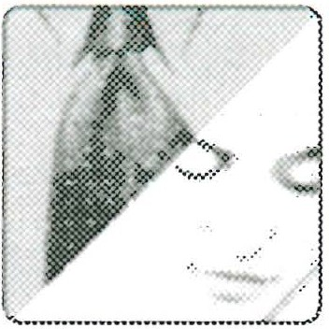

affect his wife all day and still be bothering her when they reconnect at day's end. The husband has probably forgotten all about whatever happened earlier because he has compartmentalized it-shoved it aside where it can't bother him. His wife, however, is an integrated personality who does not compartmentalize things. Everything is con-

r'l.ected and one small remark that hurts her stays with her until the hurt is repaired. 1alk together about what this can mean to each of you in different situations, for ex­ ample, if you are invited out for the evening . . . if you planned to work together on something related to the house . . . if he hoped to make love that evening.

In "Wives See Husbands As Mysterious Islands" (book pages 137-39), Emerson describes a typical phenomenon: the husband is open, communicative, and charm­

3

ing during courtship, but after getting married he closes up. Why does this happen? How does it make the marriage vulnerable to the Crazy Cycle?

98 *OSC>* PA RT rlw o-TH E ENERG IZING CYC LE

This could be a sensitive question, particularly if the husband thinks *hF*

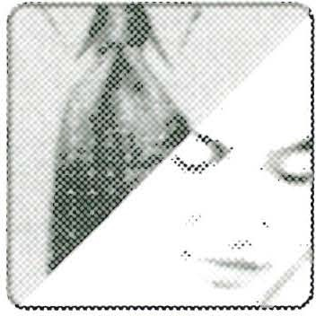

is being acused of doing one thing during courtship and then .the reverse ., after marriage. Compare what you wrote and talk about what 1s comfort­

able for both of you. His "closing down" after marriage could well be his not fully understanding how to love his wife properly. He is good-willed, but unaware (and pos­ sibly quite willing to learn). On the other hand, it is quite possible that after they got married, his wife started criticizing and being disrespectful , and then he closed up. Do not dwell on deciding if it was "the chicken or the egg." Talk together about adjust­ ments you both can make right now to keep the Crazy Cycle from starting to spin. And always be aware of the possibility that, basically, you may already be married to a loving husband or a respectful wife. There are things you can improve upon, but 80 percent or more of your marriage already consists of love and respect. Ifthis is the case, be thankful and build on that foundation.

4Do you keep your wife up-to-date? Read "Sarah Prefers . . ." (book page."-----'

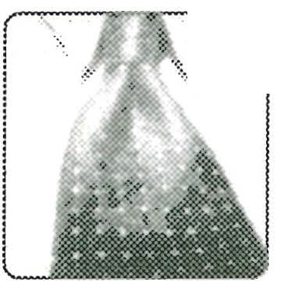

*i*

139---40) and see if you have ever struggled (or perhaps you are struggling now) as Emerson did. Following are questions a husband could ask himself if

he is tempted to think his wife is snooping or prying. How he answers each question can tell him a great deal concerning why he may not be keeping his wife informed. (Wives **should** answer these questions as **well.)**

-

|  |  |  |
| --- | --- | --- |
| Is my wife a good-willed woman? | YES | No |
| Is she trying to control me? | YES | No- |

Is she trying to connect and be close? YES-- No--

Is she trying to make me feel guilty? YES-- No--

S ESS ION Si x *os<:>* 99

Share with each other how you answered the questions above from your indi­ idual perspect.ives;, If h husband perceives the wie as coming acrss as ':pry­ mg or controllmg, this 1s her chance to reassure him of her good mtentlons.

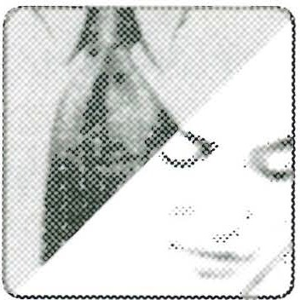

And if the husband realizes he has been reading his wife wrong (decoding her incorrectly), this is his chance to apologize for misinterpreting her heart, to say that he is sorry and from now on he will try to do a better job of decoding (and keeping her up-to-date).

,-- -In "Beware of Becoming Embittered" (book pages 140-42), Emerson describes a

*)* disturbing problem that can be caused when a husband is closed toward his wife. As he withdraws and refuses to talk about much of anything, the husband can appear to be irritated, even bitter. His wife thinks he is secretly (or not so secretly) angry with her. What can a husband do to guard against coming across as bitter or harsh? See Colossians 3: 19, and especially the letters from wives on page 142, for some simple but powerful ideas. Write down some things that may be useful in your marriage.

, -,,. 1This question may be a sensitive one fm discussion. Ifa husband is embit·

1 *L* , tred _becase he_ secretly feels.his ife s isrespectful , he may .want to. ju -

,_ · tify his attitude mstead of seemg his wife s need for love. And 1f the wife 1s

hurt by his harshness or irritation she will want to judge him as unloving and mini­ mize her own disrespectful actions. Good-willed spouses who don't want to hang on to being angry or hurt over past problems can work their way into a discussion by comparing what they found in the letters from wives on book page 142. Also, if both of you are comfortable with the idea, look at Colossians 3:19 together. Paul's words are God's command to the husband to love his wife and not be embittered toward her. Why is bitterness never effective, always destructive? If a husband tries to use bitter­ ness to "teach his wife a lesson," what kind of "lesson" will she learn? (Also note: As a husband, you may be saying this question is not for you, because you're not bitter.

100 PART Two-TH E ENE RG IZ ING CYC L E

Nonetheless, husbands must always guard against sounding or looking bitter with a harsh tone or dark countenance. If a wife is perceiving her husband as "bitter and angry," which of the following are the most useful: a loving look, a friendly gesture, a gentler tone? All of these?)

To close Chapter Ten, Emerson asks husbands a practical question: "How Will You Then Live with This Sensitive Creature?" (book pages 143-44). As a husband, what practical ideas do you find on these pages that you can or should use? As a wife, what do you see on these pages that you would like to respectfully point out to your

6

husband?

Compare what you found on pages 143-44. Husband, did you ask your­ self, "How often do I come off as harsh when I'm just telling her what I think?" Wife, did you think about, "How sensitive am I to my husband's

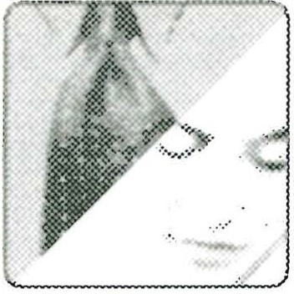

words and moods? Am I letting him know tactfully and respectfully when he steps on my air hose because he sounds harsh?"

SEss 10N Six *00* 101

7

0n book page 144, just before the chapter on openness ends, is some excellent ad­ vice for husbands concerning sex. According to Emerson, which of the following

statements is true?

To get sex I must try to appear to be more open.

If I am genuinely open to my wife, she is more likely to be open with me sexually.

:1

Talk togethe, about the 'ight aoswe<, which rathec obvious, but not ne=­

,-J a.· '-> sarily easy to practice for the typical husband. While the husband must be

·*-::.·* sensitive to his wife's need for openness, she needs to be sensitive to his need for sex. This will be covered more thoroughly in Session 12.

Look over the list of tips on book page 144. Husband, which ones are you already using? Which ones are you going to try? Wife, which of these tips would you like

8

to have your husband try?

,--

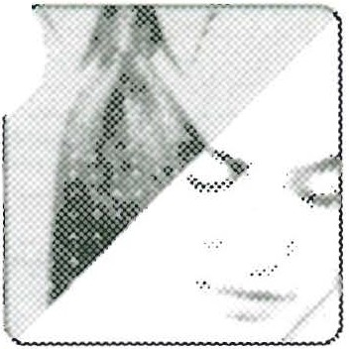

Share together about these ideas and how they might help your relation- ship. For starters, a husband should try at least one idea that he and his wife agree would be helpful.

**Question s for Chapter Eleven**

Chapter Eleven opens with a discussion of 1 Peter 3:7, which says a husband should live with his wife in an understanding way because she is the "weaker partner" (NN)

9

or "weaker vessel" (NKJV). Feminists tend to bristle at this, claiming it says men are stronger, and therefore superior to women. What has been your understanding of

102 *c:so* PA RT Two-TH E ENERG 1z 1 NG CYCLE

"weaker partner"? Write your thoughts here, then compare them to Emerson's expla­ nation of what the verse means on book pages 145-46.

Discuss what you each wrote about 1 Peter 3:7. What do you think Emerson means when he says the wife is the weaker vessel (or partner) "because of her vulnerability to her husband within the marriage relationship"?

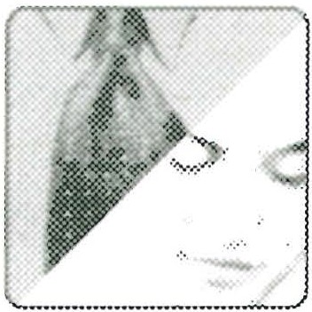

ln ''Always Handle Porcelain with Care" (book pages 146-47), wives are see'll as porcelain bowls and husbands as copper bowls . Is this a good analogy? Why

1O

or why not? What does this comparison have to do with the husband needing to "understand" his wife?

SEss10N Six *00* 103

Compare notes on your reaction to the porcelain/copper analogy. Talk about times when a wife wants to be "handled with care." What are some specific ways a husband can do this?

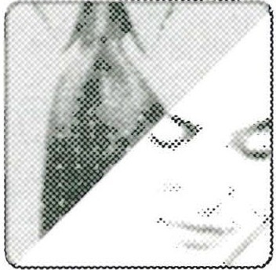

The bottom half of page 147 talks about something you may have noticed: The principles in C-0-U-P-L-E connect and even overlap. How can practicing closeness and openness help a husband with understanding his wife? Write your ideas

11

here.

,,.----

Compare what you wrote. As you work on the rest of this session, take note when anything you wrote above matches up with some of the key truths in the rest of Chapter Eleven.

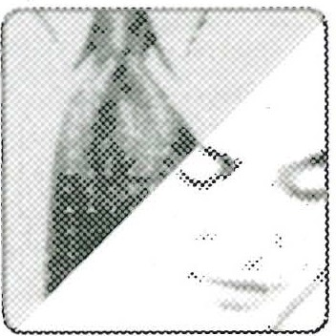

Read book pages 148-51. What does Sarah usually want from Emerson-a "solution" or a listening ear? How is the man's typical desire to "fix" whatever

12

seems to be wrong an example of "blue" thinking? How is the woman's typical desire

to "just want to talk" an example of "pink" thinking?

104 *'*'* PA RT Two-TH E ENE RG IZ ING CYC LE

Compare yourselves with Sarah and Emerson. Does the wife usually want to "just talk"? Does the husband prefer to exchange information, come to conclusions, or "fix a problem"? If the two of you fit this profile, how doer

E

it sometimes lead to problems? What can each of you do about it? , ,,

" 'Just Talking' Is a Key . . ." (book pages 151-52) presents some valuable help for men who are trying to show their wives understanding. Husbands, read this

13

section carefully, then list key phrases and sentences you want to remember and ideas you want to try. Wives, what do you see in this section that describes you? How im­ portant is "just talking" to you?

Compare notes on what you have each written above. If "just talking" is even moderately important to the wife, she can elaborate on why this is true. Wise husbands will "just listen" and try to understand .



SESS ION Six *00* 105

Do you agree that "Understanding Takes Scheduled Time"? (See book pages

14

152-54.) How does this idea strike you? Be totally honest.

1. I agree completely and already do this, or plan to do this regularly.

b. I'm not sure it would work . . . What would we talk about?

c. I'd like to try it, but doubt we have the time.

d. I think understanding is something you feel, not something you schedule.

,-- ',

1. I think:

Compare answers, then discuss how useful it would be to schedule time to talk. (See Emerson's additional comments on answers *b, c,* and d in *Work­ book* Appendix VI.)

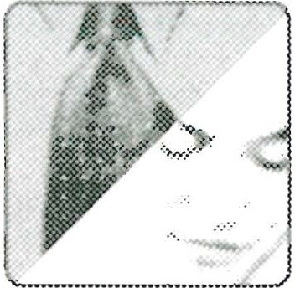

Look over the list of tips at the bottom of book page 154. Husbands, pick at least one thing you will try this coming week. Wives, choose at least one thing

15

-vou would like your husband to try this coming week. Write your choices here.

Compare your choices and agree on what the husband is going to try. (The wife shold not be j dgmntal if her husband doesn't perorm flawlessly. Be encouragmg as he tnes thmgs that are probably new to him.)

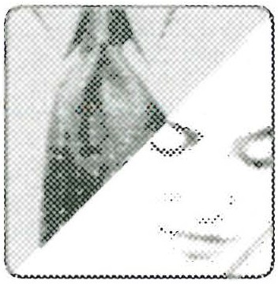

106 c6<:> PA RT Two-THE ENERGIZING CYCLE

A JOU RNAL OF MY JOU RN EY TO LOV E AN D RES PECT

Take time to add your thoughts to the points below as you continue to create a record of your journey toward Love and Respect.

SCRIPTURE MEDITATIONS

1. Proverbs 31: 12 says, "She does him good and not evil all the days of her life." Do you believe this about your wife? Does this motivate you to be more open with her? . ,·
2. The wise husband is "quick to listen, slow to speak" Qames 1:19 NIV). As you deal with your wife, do you find it easier to give solutions or give empathy (put yourself in her shoes and think about how she feels)? If you are more solution-oriented, recall a recent conversation with your wife where it would have been better to listen than to speak. Would it help to pray daily asking God to help you be more empathy-oriented?
3. In 1 Peter 3:7, the apostle tells husbands to ". . . live with your wives in an under­ standing way . . . show her honor as a fellow heir of the grace of life." God has made your wife with needs and vulnerabilities that are different from yours. Can you name some of them? Do you find yourself being impatient with some of her needs or vul­ nerabilities? How can you begin treating her with more understanding and respect in one or two of these areas?

**My current thoughts about our marriage:**

# SESSI ON SEVEN

In preparation for this session, read Chapter Twelve, "Peacemaking-She Wants You

,-- to Say, Tm Sorry."' The following questions are for study by an individual or by a hus­ Jand and wife studying together. Remember. to answer all unmarked questions first, then answer questions marked by the male or female icon (whichever applies to you). Finally, answer the questions with the couple icon, if you're studying with your mate. (Suggestions for anyone planning to use this study with a small group can be found in

*Workbook* Appendix I, page 201.)

1

On book page 156, Emerson introduces what he calls "the fourth side to connec­ tivity"-peacemaking-and adds that it might be even more important than the three principles you have studied so far in C-0-U-P-L-E: closeness, openness, and understanding. As you began reading this chapter, what was your response to seeing peacemaking as a major principle for a husband to employ in "spelling love to his

wife"? Choose from the statements below, or write your own response.

a. "Peacemaking" suggests there has been a fight; frankly, I always try to avoid conflict. I just want us to get on with our lives.

b. The best way to resolve a fight is to speak your mind and then drop it and move on.

c. I don't want to sound arrogant , but if my spouse would defer to my good judgments we wouldn't have these arguments and peace would reign.

* 1. Feeling at peace, because things are up-to-date with nothing between us, has a lot to do with my feeling okay about our relationship.
  2. I think:

108 cs<:> PA RT Two-THE ENERGIZING CYCLE

Husband, which of the comments above captures your feelings? Wife, hich stateent captures yours As thi session of study will show, it is vital for a wife to feel at peace, with nothing between her and her husband.

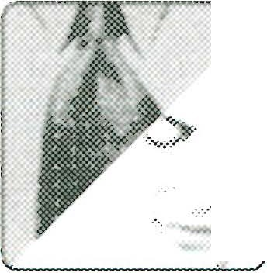

Continuing on book page 156, Emerson mentions a "paradox" he found as hr studied the Scriptures: "God intended for some conflict to exist in a marriage." He'-../

2

goes on to say that secular research confirms that the best marriage relationships have conflict and that it almost seems that a marriage needs to have some conflict to keep the passion in it. What do you think? Do you agree that conflict puts just enough spice in marriage? Choose from these responses, or write your own:

a. Sometimes conflict helps; sometimes it doesn't.

b. Conflict is never good; it squelches passion for me.

c. A little conflict is good, because it's fun to make up afterward. d. I think:

Discuss your answers, then compare your conclusions to what Emerson says about the risk involved when "the sparks fly" (book pages 156-57).

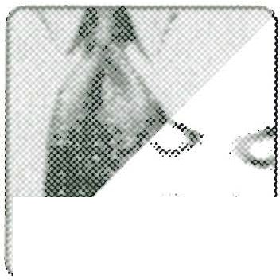

.....................-..·..--··

In "Husband and Wife Can 'Work It Out,'" book pages 157-58, Emerson makes some comments that may be new to you concerning how spouses can deal with conflict in their marriage. Read these pages carefully, then jot down phrases or sen­ tences that strike you as a different approach to working out conflict. (If you are study-

3

SESS ION SEV EN *00* 109

ing with your spouse, you can discuss what you find at this point, or wait until Question 4.)

What in particular does Emerson say on book pages 157-58 about how couples should view a conflict over sex? To put it in practical terms: "Tonight, after a par­ ticularly stressful day for both of you, who decides if you will be sexually intimate? First Corinthians 7:3-5 says both spouses have authority over the other's body, so who decides?" When Emerson speaks at Love and Respect Conferences, his answer to this question is: "Yes!" This usually gets a laugh, but the real answer is found in 1 Corin­ thians 7:5, plus what Emerson says on page 158. How would you sum up his descrip­

4

tion on page 158 of "one of the great principles of the New Testament"?

Discuss the ideas you both put down, then compare your conclusions with Emerson's further thoughts on this crucial question. (See Emerson's addi­ tional comments in *Workbook* Appendix VI.)



110 PA RT Two-THE ENERG IZING CYCLE

5

In "My Wife Is Always Getting Historical," book pages 158-60, Emerson gives husbands another important tip for making peace. Husband, as you read this sec­ tion, think about how "historical" your wife has been or can be. Does she bewilder you with her seemingly endless memory? Wives, how do you see yourself regarding your

tendency to "get historical" with your husband?

1. Extremely historical (memory like an elephant)
2. Somewhat historical (might bring something up now and then)
3. Not historical at all (never bring up anything from the past)
4. I think:

Compare your perceptions. What does the husband think of his wife's his­ torical propensiies? Des she gree that she can e his:oric ? Discuss your answers. If tension begins to nse, try to keep things light: May I borrow

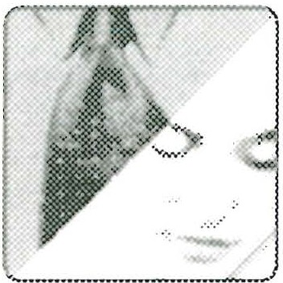

your pink/blue hearing aids? I need help understanding what you're trying to say." (For more "lighten things up" ideas see *Love & Respect* Appendix A, page 307.)

According to book page 160, why is it usually not helpful for the husband to say, "Let's drop it-just forget it"? At the bottom of page 160, what does Emerson rec­ ommend a husband say if he wants to make peace with his wife? Write out these three

6

short sentences below and commit them to memory.

S ESS ION SEV EN '*' 111

Take plenty of time to discuss this one. Be sure to read the letter from the frustrated wife on book page 160. Work together on the real issue: love for her, respect for him.

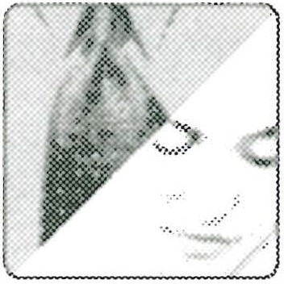

The section captioned "Why It's Hard for a Man to Say, 'I'm Sorry"' (book pages 161-62) offers important insights on how men think. Emerson speaks from experience when he observes: "When a woman says, 'I'm sorry,' to her it's an increase

7

1. *1f* love. But when a man says, 'I'm sorry,' he fears he will lose respect." Do you agree

or disagree with his observation? What does your experience tell you?

* 1. I agree on all counts.
  2. I partially agree.

1. I disagree on all counts.
2. I think (write your reasons for your answer above):

:> Read the story about the couple who had a childish fight, but then he said the Owords that made her "fall in love with him all over again." Why is saying, ''I'm sorry'' so powerful? What dynamics are at work?

l12 ssa PA RT Two-TH E EN ERG IZ ING CYCLE

Discuss your answers and share what you think of Emerson's belief that when a husband humbly expresses sorrow for what he did, his wife melts. He doesn't think many men "grasp" this. Is he right?

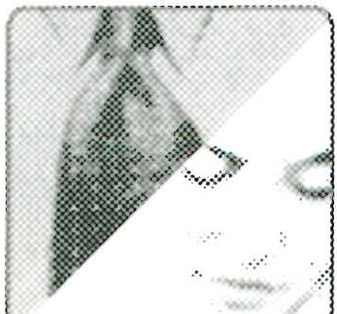

-

Which points made in "A Short Course on Peacemaking," book pages 162-64, are most helpful, in your opinion? Some of the more obvious ideas are listed below.

9

Choose from these, or find others you like as much or better :

a. A husband should have absolute confidence in the power of his lovini-:, ,, demeanor (see Proverbs 15:1).

b. When a husband says he is sorry, he must be sure he means it, or be ready for another spin on the Crazy Cycle.

c. The husband will make peace with his wife when he doesn't blame her but, instead, confesses his part of the blame (see James 5:16).

d. When a husband says, "I'm sorry,'' it's a big turn on for a woman, but an even bigger turn-on is when he adds, "I think I understand your feelings and why you react as you do. Will you forgive me?"

1. If a husband utters sincere words of apology, forgiveness, and love, his wife will trust his words and trust him. It can heal the whole thing.
2. Other points I like:

Te wife should be sre to _ fill out hr answers o the above questio a_long with her husband. Discussmg your ideas can give you both more msights into how each of you thinks.

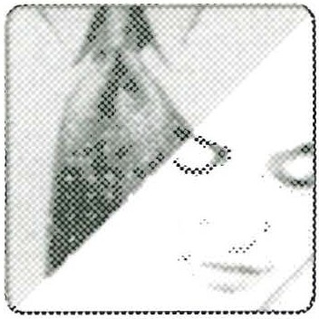

SESS ION SEV EN *00* 113

Chapter Twelve closes with a list of tips: "She'll Feel at Peace with You When

1O

. . ." (book page 164). Do you *see* anything else here that would help the peace­ making process in your marriage?

As you compare notes on this question, you might want to review your answers to Question 9. Then, agree on one thing the husband can do dif­ ferently during the coming *week.* When he attempts to practice what you

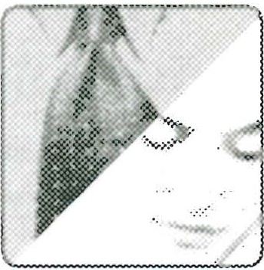

both have agreed upon, if at all possible, stop and talk about how it worked, how it felt. Always *be* positive and encouraging to one another. If he makes real progress on his "one thing to do differently" go over the tips and ideas again and choose another action or attitude he can use to improve your peacemaking process.

A JO U RNA L OF MY JOU RN EY TO LOVE AN D RES P E CT

, --,, uild another "chapter" of your journal to Love and Respect by interacting with the following points.

SCRIPTURE MEDITATIONS

1. After giving advice to wives and husbands in 1 Peter 3: 1-7, Peter writes this sum­ mary: ". . . all of you *be* harmonious, sympathetic, brotherly, kindhearted, and hum­ ble in spirit" (v. 8). As a spouse, which of *these* do you do best? Which does your

spouse do best? Do you both bring strengths to the marriage that can make for peace?

1. "If possible, so far as it depends on you, *be* at peace with all men" (Romans 12:18). Peace is possible if you believe the other person wants to *be* at peace with you and will

114 *00* PA RT Two-TH E ENE RG IZ ING CYC LE

respond if you take the initiative. As a husband, do you have faith that if you were to apologize for being unloving, your wife would respond? As a wife, do you have faith that if you were to apologize for being disrespectful, your husband would respond? If your answer is yes, then as far as it depends on you, you can be at peace with your spouse.

1. "Be humble in the presence of God's mighty power, and he will honor you when the time comes" (1 Peter 5:6 CEV) . We fear that if we seek to make peace by humbling ourselves and confessing our lack of love and respect, our spouse will not reciprocate. Ultimately, however, this is not about our humility before our spouse, but beinr humble in the presence of God. According to this verse, when we are humble in th presence of God what eventually happens? How can we have the courage to humble ourselves in this way (see v. 7)?

**My current thoughts about our marriage:**

# SESSI ON EI GH T

,.--ln preparation for this session, read Chapter Thirteen, "Loyalty-She Needs to Know iou're Committed," and Chapter Fourteen, "Esteem-She Wants You to Honor and Cherish Her." The following questions are for an individual or a husband and wife studying together. Remember to answer all unmarked questions first, then answer ques­ tions marked by the male or female icon (whichever applies to you). Finally, answer the

questions with the couple icon, if you're studying with your mate. (Suggestions for any­ one planning to use this workbook with a small group can be found in *Workbook* Appendix I, page 201.)

#### Questi on s for Chapter Th i rtee n

Read the opening of Chapter Thirteen on book page 165. What are your first impressions of the idea that a wife needs reassurance of her husband's love?

1

Which of the following responses comes close to yours? (Or write your own.)

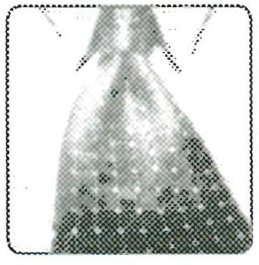

* 1. I'm well aware that my wife needs reassurance of my love, and I try to

provide it whenever I see (or hear) that she needs it.

ll6 *00* PA RT 1wo -TH E EN rnG 1 z1NG CYC LE

* 1. Have never thought much about it-she knows I love her, why do I have to keep telling her?
  2. Reassurance? Every time I try to tell her I love her, she tells me I don't mean it, or I'm just saying that because I want sex.
  3. I think:

What is your reaction to page 165? Is reassurance of your husband's love something you like to hear fairly often? Check the answer that comes close to your ideas (or write your own).

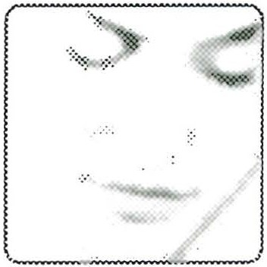

a. Reassurance is important to me, and I think most women feel the same. b. I've had my husband use that "Don't worry, I'm not going to trade you

in for a new model" line, and I didn't think it was that funny.

1. My husband is always telling me he loves me, and I never get tired of hearing it.
2. I think:

Compare notes on your answers checked or written above. Ifyou both feel about the same concerning the importance of a husband's loyalty, be encouraged. On the other hand, it is possible the two of you will not agree

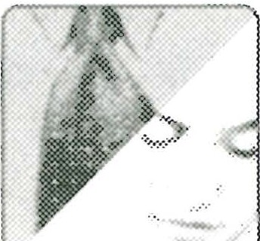

,_ _ _

on the importance of loyalty, or even what loyalty looks like in a marriage. For exam­ ple, it is not unusual for the husband to be rather unaware of how important it is to

SESSION EIG HT *c:so* 117

reassure his wife of his loyalty and his love. The good-willed husband who falls into this category should be willing to learn as he proceeds with this session.

Read the letter from the wife at the top of book page 166. How does her husband reassure her? Are there any key words or principles you appreciate or find useful?

2

Write them here:

Compare notes on what you see in the wife's letter that might be helpful in your own marriage. Spend some time on how the wife tells her husband she feels "emotionally disconnected" from him at certain times and what he



does about it. Is 'Tm feeling disconnected" something one or both of you might be able to say to communicate a need, or would it just trigger arguments?

2.Read the sections "She's a One-Man Woman . . ." and "It's a 'Swimsuit Issue'

, .}World," book pages 166-68. Is a wife being overly sensitive if she wonders about her husband's commitment, particularly with the barrage of beautiful females that bombard his eyes daily-in person and in the media? Choose from the following answers, or write your own opinion.

a. A wife can't help but wonder sometimes.

* 1. Either spouse might struggle with commitment .
  2. It would be nice for a wife to be reassured now and then, especially as her body reflects the aging process.

118 0':> PA RT 'Iw o-TH E ENERG 1z 1 NG CYc LE

d. What's a man to do? His wife should know he might look, but she has nothing to worry about.

1. Ithink:

This can be a sensitive issue, so beware of stepping on your mate's air hose Try comparing the answers you checked or wrote . Wife, if you do feel at least a little insecure, let your husband know without condemning him.

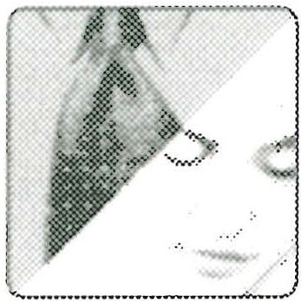

Husband, how can you reassure your wife of your commitment? Does Job have some good advice when he says: "I made a covenant with my eyes not to look lustfully at a girl" (Job 31:1 NIV)?

How does Song of Solomon 8:6 catch a wife's deep feelings about needing to always be sure of her husband's loyalty? Also read Emerson's thoughts on the wedding ring

4

(book page 168). Why is a wedding ring so important? Write your ideas here:

Be sure not to skip this one. Share honestly with each other about your per­

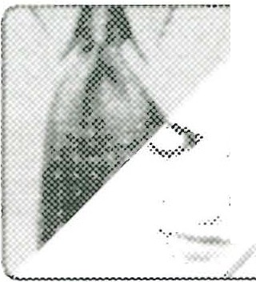

:

spective on wearing a wedding ring. Is Emerson right when he says: "No

, husband should leave home without one"? Why or why not?

SESSION EIG HT 00 119

The prophet Malachi warned Israel against the prevalent practice of easy divorce that was going on in Israel as husbands dealt treacherously with their wives (see Malachi 2:14-15). Read ''Are You Being As Loyal As You Could Be?" (book pages 168-69). Emerson is not saying that today's good-willed husband is trying to be treacherous toward his wife-but what is he saying? How can heeding Malachi

5

2: 14-15 help keep you and your spouse off the Crazy Cycle?

Discuss your answers to this question with sensitivity to each other. Try to dwell on the positive idea that "his love motivates her respect." A big part of a husband's love for his wife is being loyal in every way he can think of

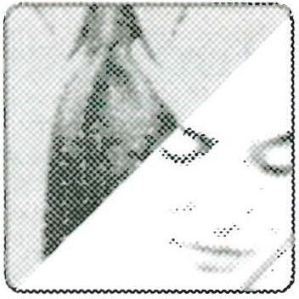

In Malachi 2: 16, the prophet tells husbands, ". . . take heed to your spirit, that you do not deal treacherously [with your wives]." Is this passage only for husbands in Malachi's time, or is this also a warning for today's husband to be on guard against things that can undermine faithfulness to God and his wife? What are some of those "things" that can tempt a husband to be unfaithful?

*('*

120 *c:so* PA RT Two-THE ENERGIZI NG CYC LE

0n book pages 169-70 read the story of Robertson McQuilken, who left his position as a seminary president to care for his wife who was slowly dying of Alz­ heimer's disease. What does McQuilken's "sacrifice" tell you about the meaning of be­ ing loyal as a husband? Write down some of the thoughts he expressed when he faced

6

his decision.

You and your mate may want to read Robertson McQuilken's story to­ gether, then share our thoughts. See especially th quote, ": lmost all women stand by theu men; very few men stand by their women. How can



a good-willed husband turn this statement from a possible guilt trip into a motivator

to be more loyal to his wife?

'-...-//

Which of the tips included in "She Is Assured of Your Loyalty When . . ." (book pages 171-72) could be a real help in sparking the Energizing Cycle for your marriage? Pick out one and write a brief reason why this particular idea could help

7

you and your spouse.

SESS ION EIGHT c:5<:> 121

Compare your choices, then agree on which tip the husband should prac­ tice during te comin? week. Ifyou each have a strong preference, perhaps he can practice both ideas. Be sure to talk about and encourage what he

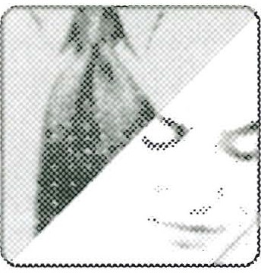

decides to live out on a daily basis.

##### Question s for Chapter Fourteen

**O**Wives often ask where Scripture talks about the husband respecting his wife. On

--- book pages 173-75 Emerson spells out what it means for a husband to respect (honor and cherish) his wife. (See especially 1 Peter 3:7.) Which of the following ideas, taken from this section, are most useful to you as a spouse?

a. God has made women so that they want to be esteemed, honored, and respected.

b. The honor a wife seeks is a different kind of honor from what her hus­ band seeks as a man.

c. To your wife, respect, honor, and esteem are not qualities in and of themselves; they are components of the love she wants from you.

d. Other:

A wife studying with her husband should be sure to give her opinion on this one to se ho':" dsely it atches her husband 's choices. Talk together abut Emersons claim, Your wife wants to know that you have her on your mmd

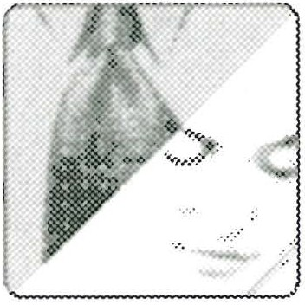

and heart first and foremost. This is what I mean by 'esteem'; when it's there, your wife will feel treasured as if she's the most loved woman on earth" (book page 175). Do you both agree he is right?

122 *'*'* PA RT Two-TH E ENERG IZ ING CYCLE

In "Our Kids Often Made Sarah Feel . . ." (book pages 175-76) Emerson shares a practical way he esteemed his wife, Sarah, at a critical time in their marriage . What

9

did he do, and why was it effective?

*)*

Ifyou have children growing up in your home, this story can be very appli­ cable to your marriage at this time. Parenting is difficult at best. What does the final paragraph in the section tell you about why morns usually need

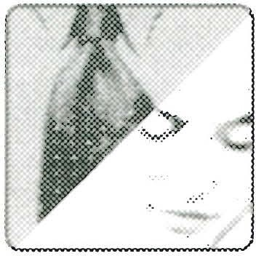

more support and encouragement than dads as they do parenting tasks?

*)*

Back in Session 1, question 8 dealt with the time Emerson forgot Sarah's birth­ day-completely! This was good for several more turns on the Crazy Cycle for

1O

both of them. For further insight on how much store women put in birthdays and an­ niversaries, read "Use Symbols to Show Your Wife Esteem" (book pages 176-79). Following are some quotes from this section. Write down your response to each of Emerson's observations, whether you agree or disagree and why.